LET’S LEARN ABOUT SUDAN AND SOUTHERN SUDAN – a terrible equation:
OCCUPATION + INDEPENDENCE + Civil War #1 + Civil War #2 + independence + a new nation + another civil war = a big, sad, tragic mess!!!
SUDAN
- Was once the ___________________ country in Africa
- The south split away from the north IN 2011 so now we have SUDAN and ________________
- Sudan split in two because the ___________ and ____________ could not get along…they still don’t.
COLONIZATION
- _____________ established colonial rule and controlled the region (Sudan) in the 19th century.
- In 1924, the British divided the region into two territories: the Arabic-speaking _________ north, and the mostly English-speaking __________________ and Animist south.
THE NORTH
- The northern region is home to mainly _______________ Muslims.
THE SOUTH
- But in the southern region, there is no dominate culture. The____________________ and ___________________are the largest of nearly 200 ethnic groups.
THE______________ nation of cattle herders live in the ____________of Sudan.
THE ____________nation of cattle herders live in the _______________ of Sudan.
INDEPENDENCE
- In 1956, Sudan gained its independence from __________________, but there was still a lot of tension between the north and south.
Turn…Talk… Write - Based on the video, HOW WOULD YOU SUMMARIZE THE CURRENT SITUATION?

POLITICAL CATOON ANALYSIS
Who is the cartoon depicting (showing)? What are some details that you notice in the cartoon? What does this image tell you about the cartoonists view of the future?
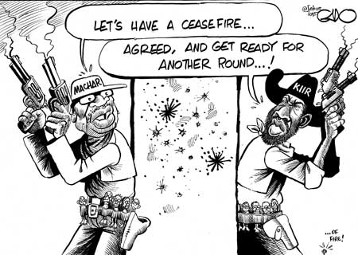

RACE RESPONSE:
__________________________________________________________________________________________________________________________________________________________________________________________________________________________________________________________________________________________________________________________________________________________________________________________________________________________________________________________________________________________________________________________________________________________________________________________________________________________________________________________________________________________________________________________________________________________________________________________________________________________________________________________________________________

