Name_________________________________ Date ____________ Period ____

Read the following quotes and respond to the questions which follow:

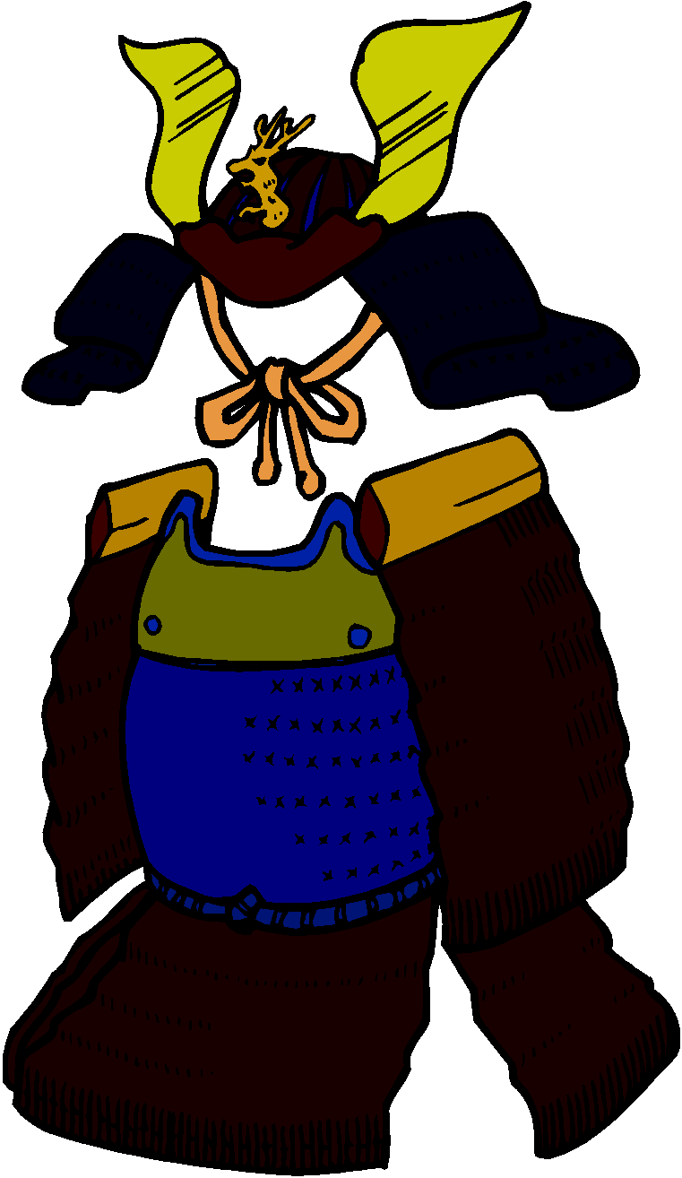
QUOTES FROM THE SAMURAI CODE

#1. “The Way of the Samurai is found in death. When it comes to either/or, there is only the quick choice of death. It is not particularly difficult. Be determined and advance. To say that dying without reaching one’s aim is to die a dog’s death is the frivolous way of sophisticates. When pressed with the choice of life or death, it is not necessary to gain one’s aim. We all want to live. And in large part we make our logic according to what we like. But not having attained our aim and continuing to live is cowardice. This is a thin dangerous line. To die without gaining one’s aim is a dog’s death and fanaticism. But there is no shame in this.”

#2. “Meditation on inevitable death should be performed daily. Every day when one’s body and mind are at peace, one should meditate upon being ripped apart by arrows, rifles, spears, and swords, being carried away by surging waves, being thrown into the midst of a great fire, being struck by lightning, being shaken to death by a great earthquake, falling from thousand foot cliffs, dying of disease or committing seppuku (ritual suicide) at the death of one’s master. And every day, without fail, one should consider himself dead.”

#3. “A man is a good retainer to the extent that he earnestly places importance in his master. This is the highest sort of retainer. If one is born into a prominent family that goes back for generations, it is sufficient to deeply consider the matter of obligation to one’s ancestors, to laydown one’s body and mind, and to earnestly esteem ones master. It is further good fortune if, more than this, one had wisdom and talent and can use them appropriately. But even a person who is good for nothing and exceedingly clumsy will be a reliable retainer if only he has the determination to think …A person who serves when treated kindly by the master is not a retainer. But one who serves when the master is being heartless and unreasonable is a retainer.”

YOU MUST ANSWER THOROUGHLY AND IN COMPLETE SENTENCES

- WHY did a samurai have to meditate on death every single day? Explain thoroughly

- Explain the second quote – what is meant by the word “retainer”?

- Could YOU have lived as a samurai – why/why not?

