Quizizz

Judaism, Islam, Christianity

Name : Class : Date :

- How many times do Muslims have to do the ritual of prayer?
  - 3 b) 1

c) 2 d) 5

- What is the pilgrimage to Mecca called?
  - Kaaba b) Tajj
c) Hajj d) Medina

- What is a major holiday in Muslim culture?
  - Ramadan b) Christmas
c) Kwanzaa d) Hannukah

- How are the Five Pillars in Islam and Ten Commandments in Christianity similar?
  - Guide for the afterlife b) guide for praying towards Mecca

- Guide for moral and ethical living
- guide for achieving God's forgiveness

- One obligation of a Muslim is to make at least one pilgrimage to:
  - Medina b) Mt Arafat
c) Baghdad d) Mecca

- Who was the founder of Islam?
  - Muhammad b) Moses
c) Martin Luther d) Jesus Christ

- Islam is a religion.
  - pagan b) cult
c) monotheistic d) polytheistic

- What holy city are Muslism expected to make a pilgrimage to in their lifetime?
  - Medina b) Mecca
c) Jerusalem d) Damsacus

- What is the Arabic word for God?
  - Yahweh b) Allah
c) Jesus d) Quran

- Who was the founder of Islam?
  - Mohammed b) Abraham
c) Jesus d) Confucious

- Which of the following people believe in Islam?
  - Christians b) Hebrews
c) Muslims d) Hindus

- What is the name of the holy book of Islam?
  - Bible b) Torah
c) Qu'ran (Koran) d) Four Noble Truths

- What city do Muslims need to face when they pray?
  - Timbuktu b) Mecca
c) Rome d) Sumer

- Someone who believes in one God would be called a...
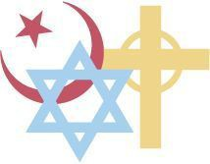
  - monotheist b) polytheist
c) atheist d) buddhist

- A Jewish place of worship is known as a
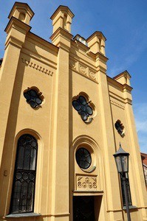
  - Mosque b) Church
c) Synagogue d) Torah

- The most sacred text to the Jews is known as the....
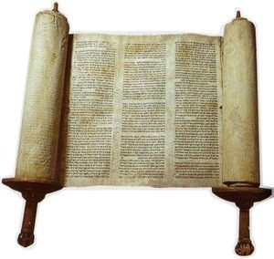
  - Exodus b) Bible
c) Covenant d) Torah

17. is considered to be the founder of Judaism.
a) Abraham | b) | Saul
c) David | d) | Goliath

- A is a Jewish house of worship.
  - synagogue b) diaspora
c) Torah

- What holidays do the Jews celebrate?
  - Earth Day b) Kwanzaa
c) Hanukkah d) All Of The Above

- Christianity and Judaism both believe in one god and are called...
  - Monotheistic b) Polytheistic
c) Atheistic d) Agnostic

- Christians believe that God is
  - All powerful b) All knowing
c) Merciful and just d) All of the above

- The holy book of the Christians is called the...
  - Torah b) Old Testament
c) Holy Bible d) Psalms and Proverbs

- What is the name of the leader of the Roman Catholic Church?
  - Patriarch b) Emperor
c) Jesus d) Pope

- Who is the founder of Christianity?
  - Abraham b) Paul
c) Peter d) Jesus

- The trinity is the belief in the
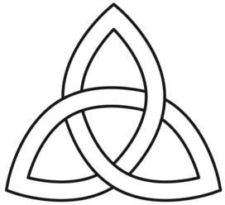

  - Father, Son and Holy Spirit b) Father, Son and Truth

- Father, Holy Spirit and the Resurrection
- Father, Discipleship, and the Son

- The Resurrection can be described as....
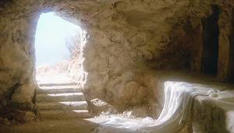
  - Jesus rising from the dead b) Jesus preaching his word

- Jesus working with his disciples
- Jesus rising the bread.

- The synagogue is to Jewish people as the is to Christians.
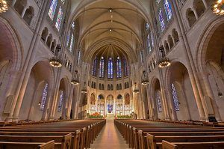
  - Church b) Torah
c) Trinity d) Synagogue

- This book contains the Old and New Testament.
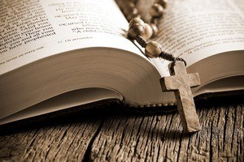
  - The Bible b) The Torah
c) The Gospel d) The Disciples

- This man was known as the founder of Christianity.
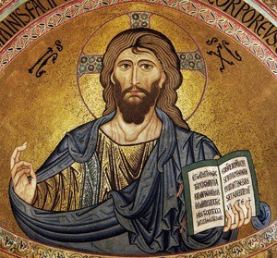
  - Jesus b) Paul
c) Isaiah d) Zephaniah

- Christianity is a religion.
  - Monotheistic b) Polytheistic

- In 2010, Mexico imposed a limit of 250,000 tons of sugar that could be imported into Mexico.
  - Tariff b) Quota
c) Embargo

- In 2010, China announced that it would impose and import a tax on American poultry of up 105.4 percent.
  - Tariff b) Embargo
c) Quota

- In 2005, the United States limited the imports of Chinese textiles to 7.5% a year.
  - Tariff b) Embargo
c) Quota

- In 2006, the United Nations passed a Resolution that prohibits states from directly or indirectly supplying North Korea with conventional weapons (battle tanks, artillery, aircraft, missiles, etc.)
  - Tariff b) Embargo
c) Quota

- Which body of water is this?
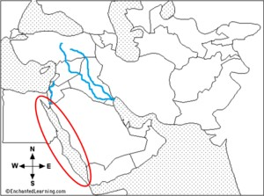
  - Tigris River b) Red Sea
c) Arabian Sea d) Strait of Hormuz

- Which person is a common figure in the origins of Judaism, Christianity, and Islam?
  - Moses b) Muhammad
c) Abraham d) Gabriel

- Which religion uses the sacred language Arabic to worship?
  - Judaism b) Christianity
c) Islam

- Islam is centered around the teachings of ?
  - Moses b) Jesus
c) Muhammad d) Gabriel

- Which religion follows The Ten Commandments as rules to guide your life?
  - Christianity and Judaism b) Judaism and Islam
c) Islam and Christianity d) None of the above

OPEC stands for the following:
  - Organization of People Exporting Country
c) Organization of Petroleum Exporting Countries

  - Organization of People Exporting Cats
d) Organization of Petroleum Exporting Continents

The purpose of OPEC is to:
  - coordinate and unify the petroleum policies to create chaos in oil markets

c) to disable the countries that produce petroleum to stabilize oil markets to secure a steady income to produces and a fair return on capital for those investing in the petroleum industry

  - to unify the countries that produce petroleum to stabilize oil markets to secure a steady income to produces and a fair return on capital for those investing in the petroleum industry
d) to unify the countries that produce petroleum to stabilize oil markets to secure a steady income to produces and an unfair return on capital for those consumers in the petroleum industry

- Tariff means:
  - a tax to pay for social services b) a tax on income paid to the
government

- a tax on purchases made on the internet
- a tax on imports or exports

- a limit on the quantity of goods that can be produced abroad and sold domestically
  - Embargo b) Quota
c) Tariff d) Market

- a partial or complete prohibition or ban between a group of countries that is imposed on imports and exports.
  - Tariff b) embargo
c) quota d) exbargo

- Which organization influences the price and the amount of oil that is produced.

  - OPEC the Organization of Petroleum Exporting Continents
c) OPEC the Organization of People Exporting Coal
b) OPEC the Organization of People Exporting Cats

d) OPEC the Organization of Petroleum Exporting Countries

Which of the following are all countries are part of OPEC?
  - Iran, France, United States,
Nigeria
c) Iran, Saudi Arabia, Iraq, Kuwait

  - Iran, Japan, Gaban, Kuwait

d) Iran, Jamaica, Phillippines, Qatar

- The economy of Israel, Turkey, Saudi Arabia, Iran are:
  - unfair b) mixed
c) command d) traditional

- is an economy in which decisions regarding investment, production, and distribution are based on supply and demand,[1] and prices of goods and services are determined in a free price system.[
  - Market Economy b) Traditional Economy
c) Command Economy d) Economic Economy

- A system where the government, determines what goods should be produced, how much should be produced and the price at which the goods will be offered for sale.

  - Parental Economy (love you Kaelyn)
  - Command Economy

  - Traditional Economy d) Market Economy

- is an original economic system in which traditions, customs, and beliefs shape the goods and the services the economy produces, as well as the rules and manner of
their distribution.
  - Market Economy b) Traditional Economy
c) Command Economy d) Control Economy

- The economy of Israel, Turkey, Saudi Arabia, Iran are:
  - unfair b) mixed
c) command d) traditional

- Which two rivers flow through the country of Iraq?
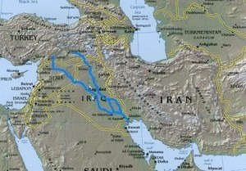
  - Jordan and Nile b) Jordan and Euphrates
c) Tigris and Euphrates d) Jordan and Tigris

- What country is this?
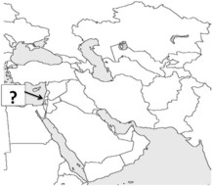

  - Egypt b) Israel
c) Afghanistan d) Pakistan

- What country is this?
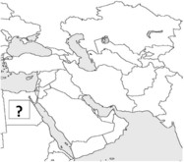

  - Egypt b) Israel
c) Turkey d) Yemen

- What country is this?
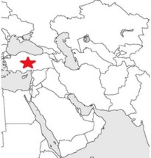
  - Israel b) China
c) Turkey d) Oman

- What country is this?
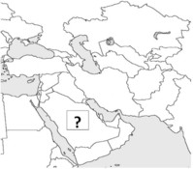
  - Iraq b) Iran
c) Egypt d) Saudi Arabia

- What country is this?
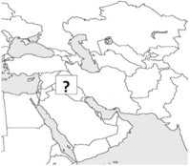

  - Iraq b) Iran
c) Turkey d) Egypt

What country is this?
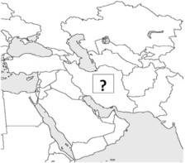

  - Iraq b) Iran

c) Israel d) Egypt

- What country is this?
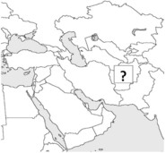

  - Afghanistan b) Pakistan
c) Iraq d) Iran

- What country is this?
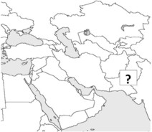

  - Afghanistan b) Israel
c) Turkey d) Pakistan

