Nigeria
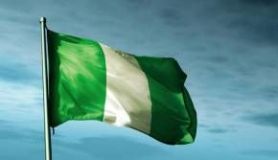

Replace each blank line with the correct information for your nation:

Capital: __________________
Area: ____________________ Population: _______________
Government: _____________
Currency/Monetary Unit:
_____________________

Language(s)
Student Name: _________________ ____________________________________

LEADING EXPORTS
(STUFF THEY SELL TO OTHER NATOINS

__________________________________________________

__________________________________________________

MORE FACTS AND FIGURES

ETHNICITY/RACE ___________________________________________

RELIGIONS ________________________________________________

LITERACY RATE ___________________________________________

List at least three historical bullet points:

*

*

*

*

*

  - Research as much of the following as you can about your nation: Go to CIA World Factbook: Kenya Government and InfopleaseKENYA - online resources where you can learn about all your assigned nation.
FACTS AND FIGURES:

Closest Ocean or Sea: __________________________

Border Countries: _____________________________

Major River(s): _________________________________

Nickname: (Base your nickname on History Facts)

