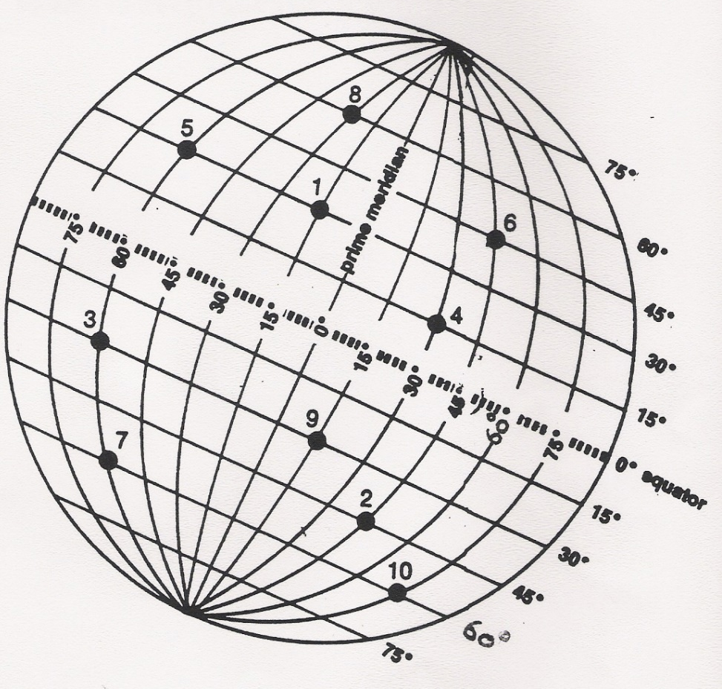
HAVE YOU LOST YOUR MOJO?

DO YOU REMEMBER HOW TO IDENTIFY ABSOLUTE LOCATION USING LONGITUDE AND LATITUDE?

LOOK AT THE ANSWER TO #1 FOR A REMINDER AND TRY THE REST YOURSELF

1. 30*N 15*W

2. __________________________________________

3. __________________________________________

4. __________________________________________

5. __________________________________________

6. __________________________________________

7. __________________________________________

8. __________________________________________

9. __________________________________________

10. __________________________________________

