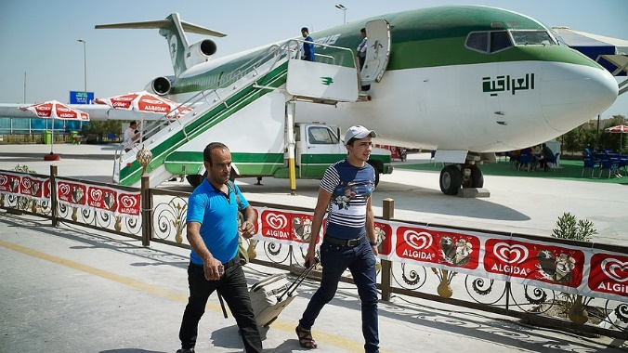
BAGHDAD, Iraq — Mohammed Falah is leaving his home. He is 24 years old and has a good life in his country compared to many other people. He will leave it behind anyway.
He will leave his wife and baby. He will also leave his house and job. "I saw this as a chance" Falah said. He hopes that someday his wife and baby can join him.

Looking For A Better Life
Falah lives in Iraq. It is a country in the Middle East. He wants to move to Europe. The Middle East is not too far from Europe. Falah is leaving Iraq because he wants a better life for his family. There have been a lot of wars in Iraq. Many people have been killed or hurt.
Falah will first fly on an airplane to Turkey. It is a country next to Iraq. In Turkey he will see many other people who are also going to Europe.
Leaders in Iraq do not want young people like Falah to leave. Falah has gone to school and he has good skills. Many young people who are leaving are like Falah. Leaders say the country needs them to stay. They could use their skills to help rebuild things.

Afraid Of The Islamic State
The fighting has made it hard for Iraq to keep young people like Falah. They are leaving even though it is not safe to travel. It is not safe to stay either.
There is fighting everywhere. Islamic State fighters are taking land. The Islamic State is a violent group. It controls parts of Iraq.
There are a large number of people already traveling to Europe. They are coming from Iraq and other countries where they are not safe. They are called refugees. A person who is forced out of his or her country or home is a refugee.
A group that many countries belong to is watching the refugees. It is called the United Nations. It says that many people have left Iraq in the past three months.

Losing Their Homes
Iraq has refugee camps for people who have lost their homes. Some of the refugees cannot leave the country safely unless they fly in a plane. Only those who have the money can go. Everybody else is stuck in the camps.
A man named Arkan Naji Obaid is at one of the camps. He is 37 years old. Obaid says the camp would be empty "if people had the money to go."
A leader in Iraq says that 1,000 people leave every day. Many are skilled workers. He worries that soon there will be nobody left with good skills.

