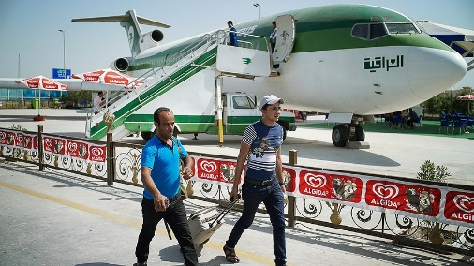
BAGHDAD, Iraq — Life is not too bad for 24-year-old Mohammed Falah. He is a civil engineer and has his own house in Iraq's capital city of Baghdad. Still, he is planning to leave it all.
Iraq is a country of more than 30 million people, bordered by Jordan, Syria, Turkey, Iran, Kuwait and Saudi Arabia. Years of war have left many people dead or injured in Iraq.

Officials Fear A "Brain Drain"
Next week, Falah will fly to Turkey. There, he will join the surge of migrants and refugees in search of a better life in Europe, making him part of what Iraqi officials describe as a "brain drain." Iraq is losing its talent and its future. Young college graduates like Falah are leaving their country to escape the violence.
The United Nations (U.N.) states that more than 50,000 Iraqis have left in the past three months. They join the hundreds of thousands already crossing the Mediterranean region. The mass exit by Iraqis has become the fastest-growing displacement crisis in the world. Displacement is when people are forced out of their homes or their country.
Nearly 3.2 million people have been forced out of their homes since Islamic State fighters began to seize Iraqi territory last year. The Islamic State is an extremist group. It wants to start its own country under Islamic law. Its fighters have taken over parts of Syria, and some of northern and western Iraq.

Looking For "A Better Future"
Iraqi officials say that a large number of those leaving are not really displaced. They are educated young men like Falah who can afford to leave.
"I saw this wave of young people who were going, many of my friends going, and I saw this as a chance," said Falah, who hopes to make it to Germany. "I'm in a better position than many people, but I want to make a better future for my family." Falah plans to leave his wife and baby in Baghdad. He is hoping that eventually they can join him legally.
Iraqi government official Joseph Sylawa said it is estimated that the number of people leaving the country is as high as 1,000 per day. "It's a death blow," he said. "Without its young people, Iraq will never be able to rebuild."

Years Of War And Car Bombs
Iraq has suffered several wars in the last 35 years. The unrest has made it hard for Iraq to hold onto its talented people. Many educated Iraqis who had left, returned after the fall of former dictator Saddam Hussein in 2003. Then, they left again when the current violence began.
Iraqis in Baghdad have now lived through the last ten years of car bombs, and more than one-quarter of the country is controlled by the Islamic State group. In addition, falling oil prices are causing an economic crisis in the country, as Iraq is a major oil producer. The growing number of militia forces that are fighting the Islamic State group is also making it difficult for the government to keep things under control. "I think about my country, and how it needs people like me" Falah said, "but my country hasn't given me anything. I need to get a future."
Twenty-five-year-old engineer Mohammed Jassim says he hopes to make it to Finland. He was at the top of his class when he graduated from college two years ago, but has struggled since to find a job, and now works at a car wash. Jassim says, "My wife and my friends encouraged me to leave. There are thousands like me that are leaving."

Forced To Flee Their Homes
Falah and Jassim are fortunate because not everyone can get out. In Iraq's camps for the displaced, many who have been forced to flee their homes because of the Islamic State cannot get to Europe. Thousands of people remain stranded in Iraq's Anbar province because they cannot get permission from authorities to leave.
Anbar province is in the west and is Sunni. Shiite Muslims and Sunni Muslims are two opposing sects of Islam, and the government is worried about the security threat of allowing people into Baghdad or Iraq's south, which is Shiite.
Ariane Rummery, a spokeswoman for the U.N., says that since it is unsafe to travel over land, many people fly to Turkey to escape Iraq. Unfortunately, only those who can pay the airfare may make it out.

Family Lost Everything
Arkan Naji Obaid, 37, and his mother are in a camp for displaced families in Baghdad. They lost everything when they were forced to flee their home in Fallujah at the beginning of 2014, when the Islamic State group seized control. Now they cannot afford to leave the country. Obaid was badly injured after an American airstrike hit his house in 2003, and he also witnessed his father's brutal murder. "If people had the money to go, this camp would be empty," Obaid said.
For those that do manage to leave, Iraqis make up just 4 percent of the over half million people who have escaped to Europe this year. However, that proportion is expected to rise. Shiite Iraqi politician Mowaffak al-Rubaie says that young Iraqis — Sunnis in particular — are struggling to envision a future. However, al-Rubaie says regardless of sect, the best of the best are leaving.

