Treasure Hunt
Digging Up Treasure in India

Learning Target: I can explain how Gandhi use non-violent resistance
to help India gain independence from Great Britain.
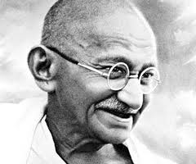
Instructions: You will use 3 websites to uncover some "Treasures" of Mohandas Gandhi and his use of non-violent resistance. For each website, browse the information given, and identify the most important parts that answer the three questions below. The five questions are meant to guide your reading, you do not need to answer them each specifically. As you read the information, fill in the graphic organizer chart to organize the information you have found. You will then summarize your thoughts in a Power Paragraph. Be clear, detailed, and specific in a Constructed Response Paragraph. Some students will be presenting their paragraphs to the class! These are the ideas we will be exploring in the Treasure Hunt
Steps:
1. Read the 5 questions that will guide your research.
2. Browse the websites.
3. As you browse, fill in the graphic organizer chart which will help to organize your information.
4. To summarize all of the information you have just acquired, write one Constructed Response in response to the following question: "How did Gandhi's use of non-violent resistance advance India's independence movement?" Be specific!

This graphic organizer summarizes the ideas we will be thinking about and areas you'll be investigating as you do your research.
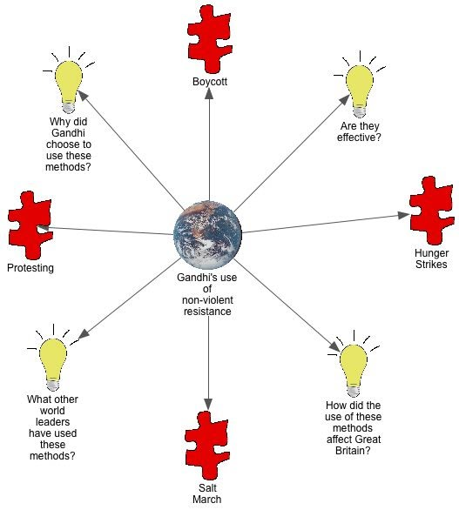

Questions:
- What are some specific examples of how Gandhi used non-violent resistance in order to gain India's independence from Great Britain?

- What is a boycott? How did Gandhi use boycotts to damage Great Britain's economy?

- What is a hunger strike? What is the point? How did Gandhi use hunger strikes to make his point?

- What was the Salt March? How was this a form of non-violent resistance?

- Do you think non-violent protests are an effective way to make an impact? Why or why not?
Website List:
- http://www.encyclopedia.com/topic/Mohandas_Karamchand_Gandhi.aspx
- http://www.brainpop.com/socialstudies/famoushistoricalfigures/mahatmagandhi/preview.weml
- http://www.mkgandhi.org/nonviolence/gandhi_and_non.htm
- http://www.pitara.com/magazine/people/online.asp?story=22

GHANDI LOOK ALIKE CONTEST – CIRCLE YOUR VOTE

GHANDI #1:

GHANDI #2:

GHANDI #3:

GHANDI #4:

Chart:

Method | What is it? | How did Gandhi use it? | How did it advance India’s movement towards independence?
Protesting
Hunger Strikes
Salt March
Boycotts

