Gapminder Fill-in Map Name Date

Identify the following countries of Africa AND use GAPMINDER to indicate the population and CAPOTOL CITY on the map below:

Egypt | Kenya | Democratic Republic of Congo (Zaire)
South Sudan | Sudan
South Africa | Nigeria
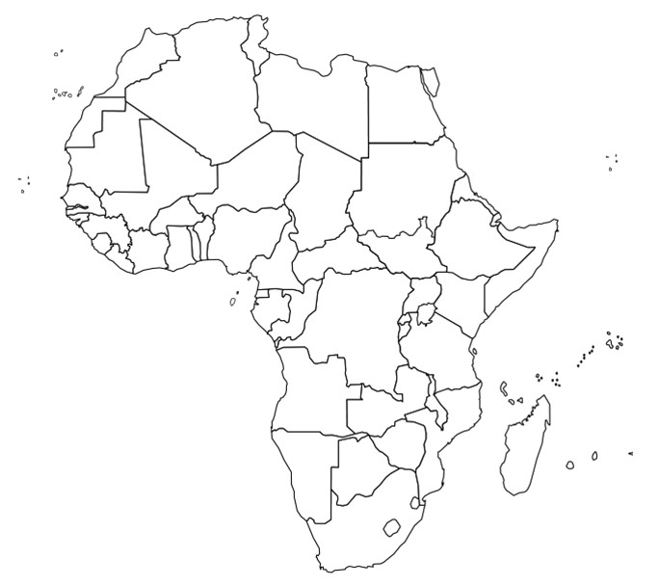
South Africa – 55.3M

Capital - Pretoria

QUESTION
- WHAT AFRICAN NATION WE ARE STUDYING HAS THE HIGHEST LIFE EXPECTANCY?

- WHAT AFRICAN NATION WE ARE STUDYING HAS THE LOWEST LIFE EXPECTANCY?

- IS THERE A CONNECTION BETWEEN LIFE EXPECTANY AND INCOME? CITE THE MAP DATA TO SUPPORT YOUR ANSWER.

