Ethnic and Religious Groups in Africa NAME_____________________________________________

- Ethnic groups share common characteristics like
  - Income, eye color, pets
  - Talent, jobs, and education
  - Language, race, and religious beliefs
  - Number of children, favorite shows, favorite food

- The Islamic faith values education because
  - Education leads to better jobs
  - So everyone can read the Quran
  - School is fun
  - They do not value education

- Sara is Arab. Why can’t it be assumed that Sara is Muslim?
  - All Arabs are not Muslim
  - All Arabs are Christian
  - Muslims are not Arab
  - Christians are not Arab

- Bantu is the largest _______________in Africa.
  - Religious group
  - Ethnic group
  - Band
  - Language group

- The Ashanti believe in
  - Supernatural and Spiritual Powers
  - The power of their ancestors
  - The Father, Son, and the Holy Ghost
  - The Lunar Calendar

- The majority of Arabs
  - Speak Arabic
  - Are Muslims
  - Both A and B
  - Use flying carpets
- What is the largest desert in the world?
  - Kalahari Desert
  - Namib Desert
  - Sahara Desert
  - Egyptian Desert

- Sudan borders which major physical feature in Africa?
  - Drakensburg Mountains
  - Atlas Mountains
  - Sahara Desert
  - Kalahari Desert

- What is the world’s longest river?
  - Niger River
  - Nile River
  - Congo River
  - Zambezi River

- Which climate zones do animals such as buffalo, gazelles, and zebras live?
  - Sahara Desert
  - Tropical Rainforest
  - Sahel
  - Savanna

13. ACTIVITY 1 Africa’s Ethnic Groups
Ethnic Group – share a common culture Religious Group - share a belief system
Ethnic Group | Location | Ancestry | Religion | Language
Arab
Ashanti
Bantu
Swahili

14. ACTIVITY 2 Directions: Identify the areas in which the Arabs, Ashanti, Bantu, and Swahili are predominantly located. Decide what symbol you want to represent each ethnic group and identify the symbol in the key provided.
15. Based on the map, where do you think ethnic and/or religious conflict would be most likely to happen?

16. Why would conflict happen in those areas?

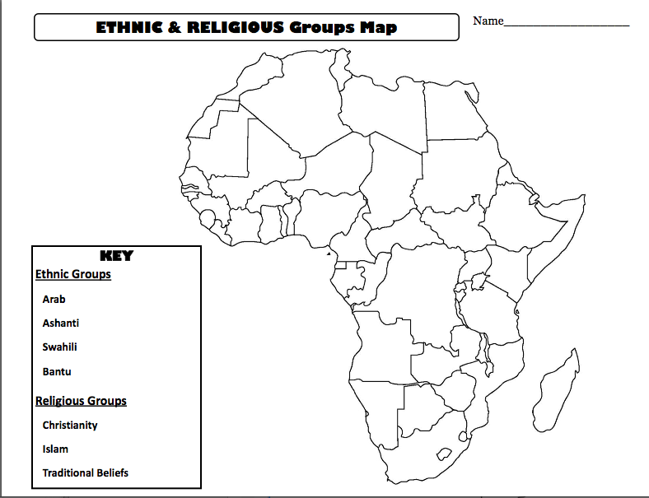

15. ACTIVITY 3: Nominal and real GDP

WHAT IS GDP? _________________________________

You are an economist who has been asked to calculate your nation’s GDP, which produces only three goods/services. Calculate GDP for Year 1 and Year 2.

GDP = price x quantity.

Year 1 GDP |  |  |  |  | Year 2 GDP
 | Price | Quantity | GDP |  |  | Price | Quantity | GDP
Oil changes | $15 | 5 | $75 |  | Oil changes | $18 | 6 | $108
Hamburgers | $2 | 20 | $40 |  | Hamburgers | $3 | 25 | $75
MP3 players | $150 | 3 | $450 |  | MP3 players | $175 | 5 | $875
 |  | Total | $565 |  |  |  | Total | $1,058

- By how much has GDP increased from Year 1 to Year 2? _____________________________________

Now calculate Year 2 real GDP using Year 1 as the base year. ___________________________

- By how many dollars was Year 1 GDP overstating GDP in Year 2? [$1,058 – $890 =
$168]

- How much has real GDP increased from Year 1 to Year 2? [$890 – $565 = $325]

 | Price | Quantity | GDP
Oil changes | $15 | 6 | $90
Hamburgers | $2 | 25 | $50
MP3 players | $150 | 5 | $750
 |  | Total | $890

