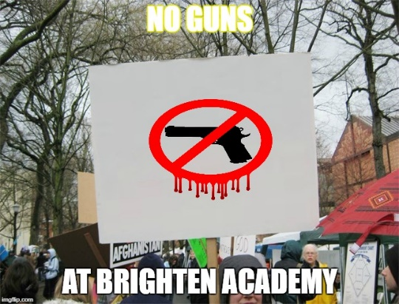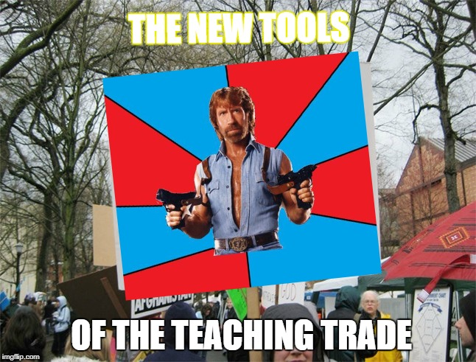
CON PRO
"Armed Educators (and trusted people who work within a school) love our students and will protect them, Very smart people. Must be firearms adept & have annual training. Should get yearly bonus. Shootings will not happen again - a big & very inexpensive deterrent. Up to States."
-President Trump on arming teachers

Question: WHAT IS YOUR OPINION? SHOULD SCHOOLS ALLOW TEACHERS TO CONCEAL FIREARMS TO PROTECT STUDENTS? Please respond in the space below:

