Africa Physical Features Formative Assessment Name Date _

Identify the Sahara, Sahel, Savanna, and Tropical Rain Forest in the map below.
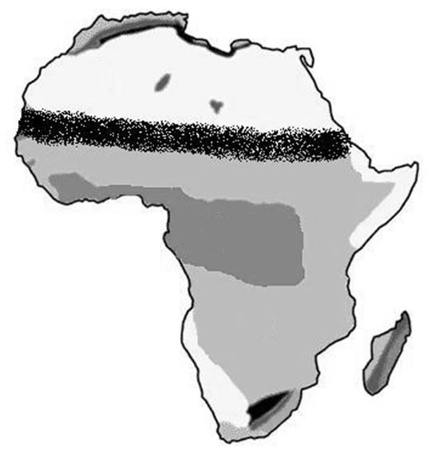
Savanna
Tropical Rain Forest
SAHARA
SAHEL

Label and draw if needed the following physical features of Africa on the map below:

- Congo River | - Nile River | - Niger River | - Atlas Mountains
- Kalahari Desert | - Lake Tanganyika | - Lake Victoria

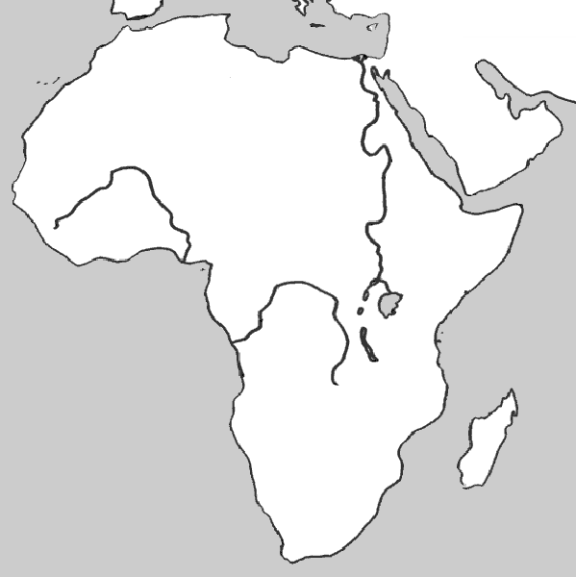
7
6
5
3
1
2
4

