Process for writing your own 6-word memoir:
- Finalize your 6-word memoir by creating two PowerPoint slides with the six-word memoir and complementary background images(s) and explanation. Be certain that the font you choose will be visible over the pictures. I highly recommend using Word Art for this. Play around with the font, the style, the colors and shades, etc., as each will factor into your overall craftsmanship grade.
- When you save your slide, the title of the file should be your name. If possible, save it as a .jpeg and either email it to me as an attachment, share it on the OneDrive, or put it on a flash drive. (If you’re working on this at school, I recommend that you either use a flash drive or save the .jpeg on your desktop before trying to email it to me.)
- Submit evidence of completion of the above steps with the checklist and rubric (on the back).
1.Save the file under your name.
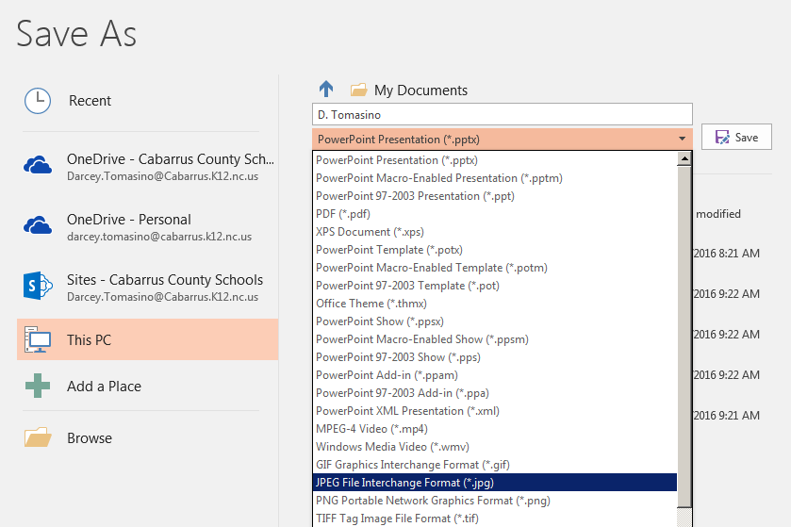
2. Use the drop down menu to save as JPEG FILE INTERCHANGE Formula (*.jpg)

3. If you’re at school, save your work on a flash drive or the desktop by clicking Browse. This will open a window that gives you the option to save in different places.

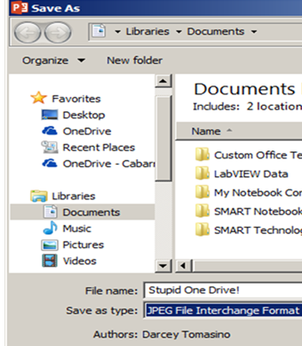
The new window will look something like this:
Name_________________________________________________ Due date____________________

6-word memoir checklist:
□ I completed the brainstorming portion of the assignment.
□ I self-edited the 6-word memoir that I like best.
□ I received feedback on my ideas and completed the peer editing checklist
□ I checked it for proper spelling, grammar, and punctuation.
□ My final product demonstrates effort and creativity: My pictures complement my memoir, and I carefully selected the font style, layout, and colors.
□ I have saved my my power point slide as a jpeg with my name as the title and either emailed it as an attachment to mdaly@brightenacademy.com and/or shared it with him on the OneDrive, or saved it on my flash drive, which I have given to Mr. Daly

Six-Word Memoir Rubric

Your Life in 6 Words | 1 | 2 | 2.5 | 3 | 3D
Six words, spelled correctly and chosen artfully | Does not meet the standard | Somewhat meets standard | Sufficient, good enough | Great job | Excellent job, surpasses expectations
Demonstrates creativity in layout, color scheme, and font choices | Little thought, effort | Some effort | Good | Very Good | Excellent, demonstrates very careful selection
Images selected to accompany the memoir are complementary and demonstrate depth of thought | Little thought, effort | Some effort | Sufficient, good enough | Very good | Excellent, visually sophisticated
No grammar or punctuation errors and no symbols (@&=+-) | Mistakes impede understanding | Several mistakes | A few mistakes | One or two mistakes | Free of grammar/ mechanical errors
Process followed (see directions and checklist) | Did not follow process | Some attempt to follow process | Followed parts of the process | Followed most of the process | Followed process as outlined

Final Grade: ___

