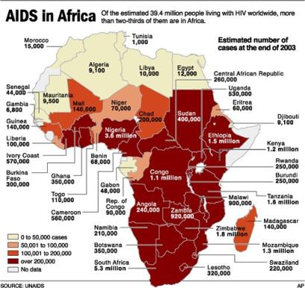
Q1 – Calculate the total AIDS population in the four nations we are studying – Sudan, Kenya, Nigeria and South Africa
_________________________________________

Q2. Which African Nation has the lowest amount of reported cases? _____________________________

Q3. Which African Nation has the highest amount of reported cases? ___________________________

Q4. Why is South Sudan not included in this report? _________________________________________

