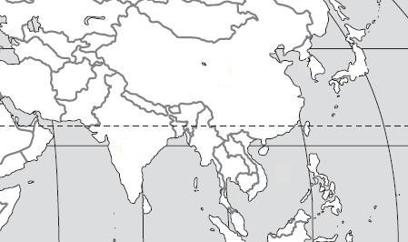
Use the maps to locate the geographic features in each question.

D
E
B
C

A

1. Bay of Bengal
2. South China Sea
3. Sea of Japan
4. Yellow Sea
5. Indian Ocean
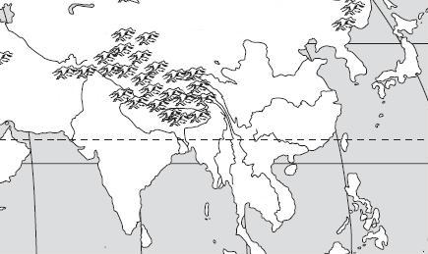

B
A
C
E
D

6. Huang He (Yellow) River
7. Chiang Jiang (Yangtze) River
8. Indus River
9. Ganges River
10. Mekong River

D
C
A4
B

11. Taklimakan Desert
12. Gobi Desert
13. Himalayan Mountains
14. Korean Peninsula
B
E
D
F
C
A
G

15. Japan
16. China
17. Vietnam
18. Indonesia
19. India
20. North Korea
21. South Korea

