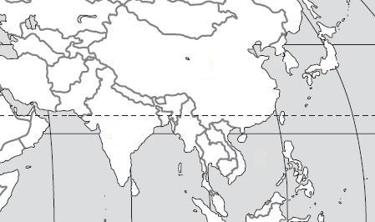
Use the maps to locate the geographic features in each question.

D
E
A
B

C

1. Bay of Bengal A
2. South China Sea B
3. Sea of Japan E
4. Yellow Sea D
5. Indian Ocean C
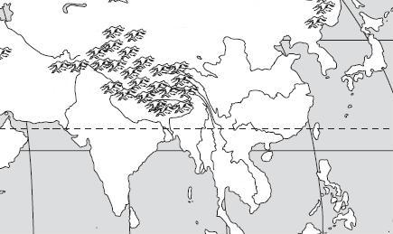

A
C
B
D
E

6. Huang He (Yellow) River D
7. Chiang Jiang (Yangtze) River E
8. Indus River C
9. Ganges River A
10. Mekong River B

C
D
B4
A

11. Taklimakan Desert A
12. Gobi Desert B
13. Himalayan Mountains C
14. Korean Peninsula D
F
D
A
B
E
G
C

H

I
K

J

15. Japan C
16. China A
17. Vietnam F
18. Indonesia E
19. India G
20. North Korea D
21. South Korea B
22. Bangladesh I
23. Pakistan H
24 Cambodia J
25. Laos K

