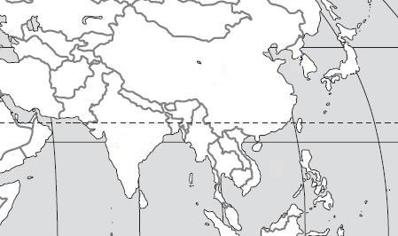
Use the maps to locate the geographic features in each question.

D
E
A
B

C

1. Bay of Bengal
2. South China Sea
3. Sea of Japan
4. Yellow Sea
5. Indian Ocean
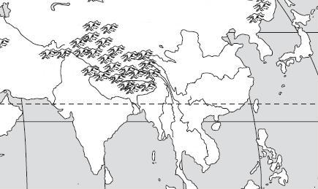

A
C
B
D
E

6. Huang He (Yellow) River
7. Chiang Jiang (Yangtze) River
8. Indus River
9. Ganges River
10. Mekong River

C
D
B4
A

11. Taklimakan Desert
12. Gobi Desert
13. Himalayan Mountains
14. Korean Peninsula
F
D
A
B
E
G
C

H

I
K

J

15. Japan
16. China
17. Vietnam
18. Indonesia
19. India
20. North Korea
21. South Korea
22. Bangladesh
23. Pakistan
24 Cambodia
25. Laos

