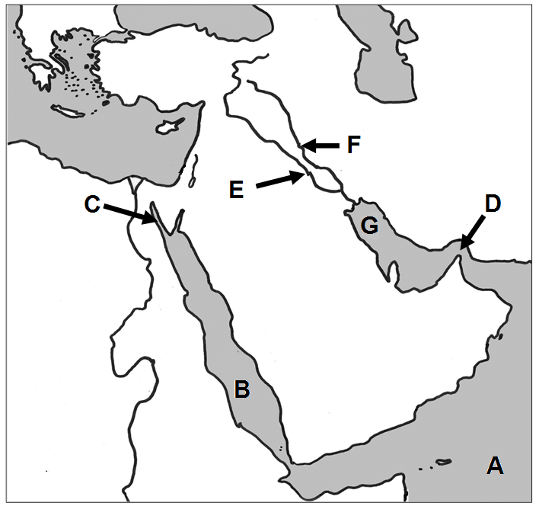
9043 Use the maps to locate the geographic features in each question.

1. Arabian Sea
2. Euphrates River
3. Persian Gulf
4. Red Sea
5. Strait of Hormuz
6. Suez Canal
7. Tigris River
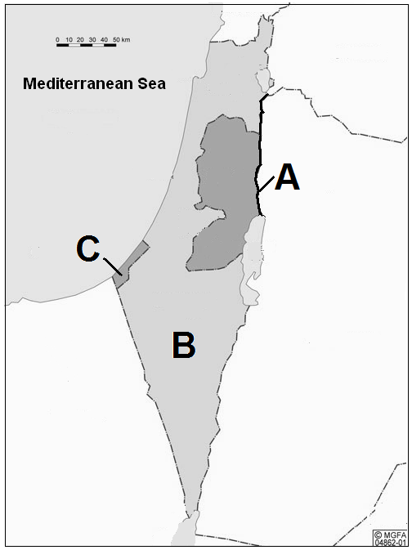

8. Gaza Strip

9. Israel
10. Jordan River
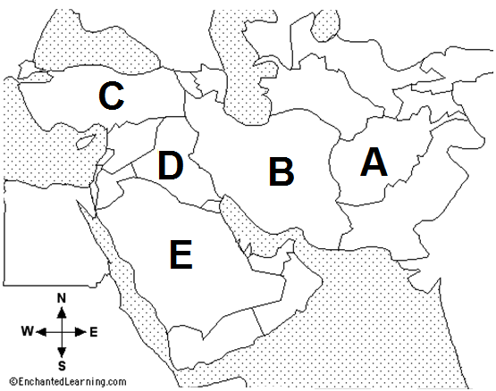

11. Afghanistan
12. Iran
13. Iraq
14. Saudi Arabia
15. Turkey

