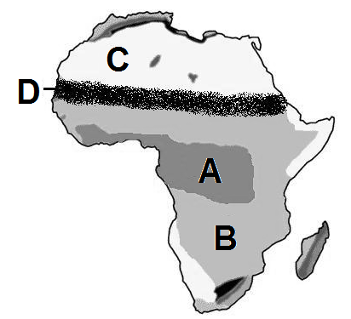
Use the maps to locate the geographic features in each question.

1. Sahara C
2. Sahel D
3. Savanna B
4. Tropical Rain Forest A
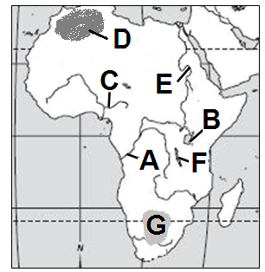

5. Atlas Mountains D
6. Congo River A
7. Kalahari Desert G
8. Lake Tanganyika F
9. Lake Victoria B
10. Niger River C
11. Nile River E
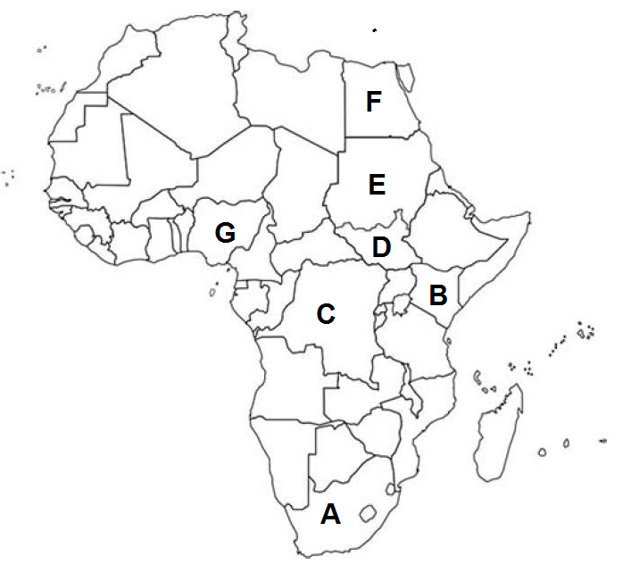

12. Congo (Zaire) C
13. Egypt F
14. Kenya B
15. Nigeria G
16. South Africa A
17. Sudan E
18. South Sudan D

