INSERT IMAGE OF NATIONAL FLAG HERE

Contents
- 1. Nation Overview
  - 2.1 Early history in Iran
- 3 Geography
  - 3.1 Climate
  - 3.2 Fauna
  - 3.3 Regions, provinces and cities
  - Border Countries
- 5 Economy
  - 5.1 Tourism
  - 5.2 Energy
  - 5.3 Education, science and technology
- 6 Demographics
  - 6.1 Languages
  - 6.2 Ethnic groups
  - 6.3 Religion
- 7 Similarities & Differences to the USA
  - 7.11 Cuisine
- 9 Bibliography
- 10 References
- 11 External links

Insert Nation Name Here
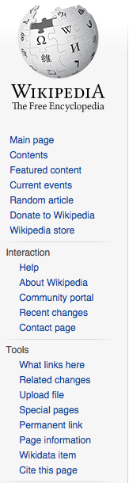

INSERT MAP IMAGE
HERE

Capital:

Official languages:

Religion

Currency

