Southern & Eastern Asia Physical Features & Countries Summarizer

The diagram below shows physical features of Southern & Eastern Asia. Label the following physical features on the map using the appropriate letter and an arrow: (A)Ganges River, (B)Mekong River, (C)Huang He (Yellow) River, (D)Yangtze River, (E)Indus River, (F)Gobi Desert, (G)Taklimakan Desert, (H)Himalayan Mountains (I)The Gobi Desert (J) Taklimakan Desert (K) Mount Everest (see example)
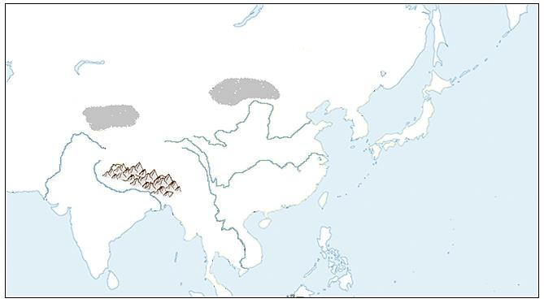
K
Label the following physical features on the map below: (L) Bay of Bengal, (M)Indian Ocean, (N)Yellow Sea, (O)Sea of Japan, (P)South China Sea, (Q)Korean Peninsula

Label the following countries on the map below: (R)China, (S)India, (T)Indonesia, (U)Vietnam, (V)North Korea, (W)South Korea, (X)Japan (Y)Pakistan (Z) Cambodia
