Quizizz

S-SEA Geo/SWA Geo/Gov't Review

Name : Class : Date :

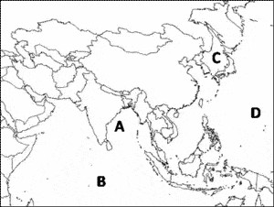
- Which letter identifies the Bay of Bengal?

  - A b) B
c) C d) D

- Which letter identifies the Indian Ocean?

  - A b) B
c) C d) D

- How has the Indian practice of cremating their dead been a problem for the river?

a) | People are not allowed to go | b) | The banks along the river
 | near the river when |  | regularly catch fire and
 | cremations are taking place. |  | threaten Indian homes built
 |  |  | there
c) | Factory owners cannot use | d) | The bodies of dead animals,
 | water once human ashes |  | as well as the ashes of human
 | have been thrown into it |  | beings, have been placed in
 | upstream |  | the river causing pollution

- Which letter identifies the Sea of Japan?

  - A b) B
c) C d) D

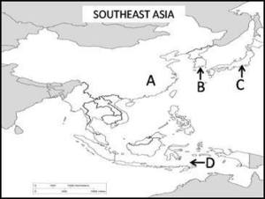
- The four countries labeled on this map are:

  - China, North Korea,
Indonesia, and India
c) China, Vietnam, Japan, Indonesai
  - South Korea, Japan, India,
Indonesia
d) China, South Korea, Japan, Indonesia

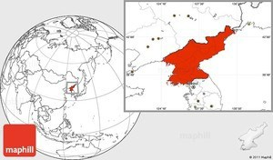
- What country is being featured?

  - South Korea b) North Korea
c) Japan d) China

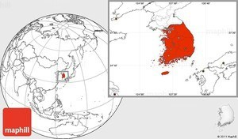
- What country is shown here?

  - Japan b) North Korea
c) South Korea d) China

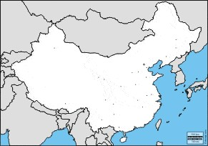
- What country is shown here?

  - Indian b) Vietnam
c) Japan d) China

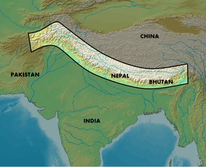
- What physical feature is shown here?

  - Gobi Desert b) Himalayan mountains
c) Taklimakan Desert d) Yangtze River

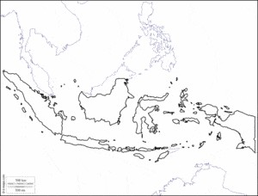
- What country is shown here?

  - Philippines b) India
c) Indonesia d) Japan

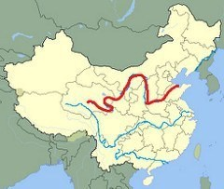
- What river is featured in red here?

  - Yangtze River b) Ganges River
c) Huang He River d) Indus River

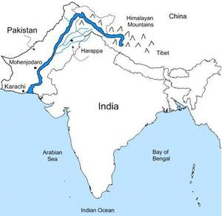
- What river is featured here?

  - Indus River b) Ganges River
c) Yangtze River d) Huang He River

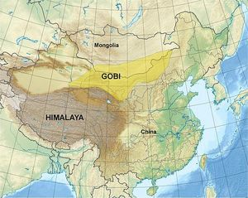
- What physical feature lies north of the Himalayas and west of the Gobi Desert?

  - Sea of Japan b) Korean Peninsula
c) Taiwan d) Taklimakan desert

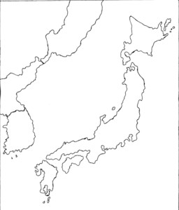
- What country is shown here?

  - China b) India
c) Nepal d) Japan

- What physical feature is shown here?
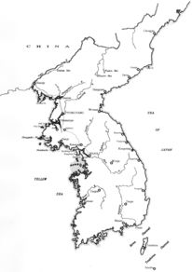

  - Gobi desert b) Korean Peninsula
c) South China Sea d) Himalayas

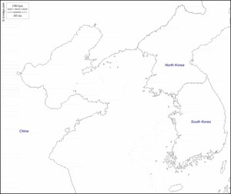
- What body of water separates China from the Korean Peninsula?

  - Sea of Japan b) South China Sea
c) Bay of Bengal d) Yellow Sea

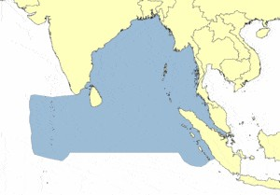
- What body of water is shaded in gray?

  - South China Sea b) Bay of Bengal
c) Sea of Japan d) Yellow Sea

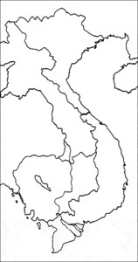
- What country is shown here?

  - Japan b) China
c) Vietnam d) India

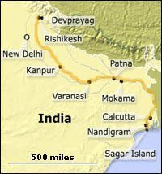
- What river is highlighted here in dark yellow?

  - Indus b) Ganges
c) Yangtze d) Huang He

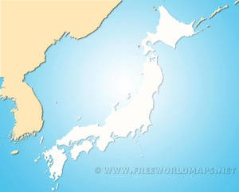
- What body of water separates the Korean Peninsula from Japan?

  - Sea of Japan b) South China Sea
c) Bay of Bengal d) Indian Ocean

- The four countries labeled on this map are:

  - China, North Korea,
Indonesia, and India
c) China, Vietnam, Japan, Indonesai
  - South Korea, Japan, India,
Indonesia
d) China, South Korea, Japan, Indonesia

- Which letter identifies the Indian Ocean?

  - A b) B
c) C d) D

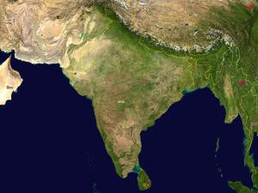
- Which of the following bodies of water DOES NOT surround, or IS NOT located near, South Asia?

  - Indian Ocean b) Bay of Bengal
c) Atlantic Ocean d) Arabian Sea

- True OR False:
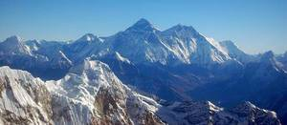
The Himalayas are located in the Southern region of South Asia (near the bottom tip of India).

  - True b) False

Mt. is the tallest mountain in the world and is located in the country of .

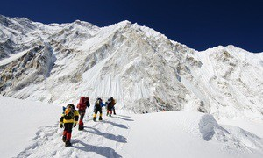

  - Everest, India b) Fuji, Japan
c) Kilimanjaro, Kenya d) Everest, Nepal

Which featured is labeled #8?
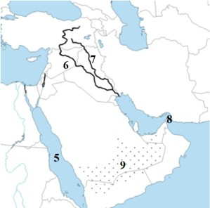

a) Mediterranean Sea b) Suez Canal
c) Dead Sea d) Strait of Hormuz

Which featured is labeled #7?
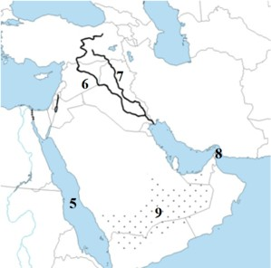

a) Ganges River b) Gulf of Aden
c) Tigris River d) Jordan River

- Which feature is labeled #6?

  - Jordan River b) Euphrates River
c) Persian Gulf d) Tigris River

- Which feature is labeled #5?

  - Red Sea b) Gaza Strip
c) Persian Gulf d) Arabian Peninsula

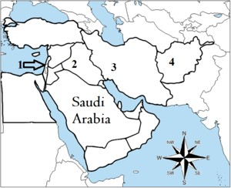
- What county is labeled #4?

  - Pakistan b) Kuwait
c) Afghanistan d) Iran

What county is labeled #3?

  - Jordan b) Pakistan
c) Iraq d) Iran

What county is labeled #2?

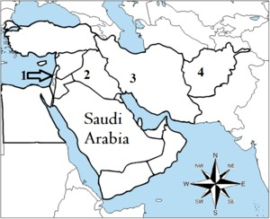

a) Syria b) Oman
c) Iraq d) Iran

What county is labeled #1?

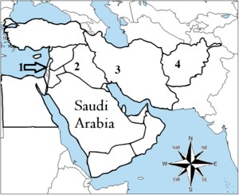

a) Israel b) Turkey
c) Jordan d) Lebanon

- If a resource is "scarce" that means the resource is
  - non-renewable b) available in abundance
c) available in small amounts d) man-made

- What canal connects the Red Sea to the Mediterranean Sea?
  - Gaza Canal b) Panama Canal
c) Persian Canal d) Suez Canal

- Population density is generally higher in areas around.......
  - mountains b) water
c) deserts d) canyons

- What is the language of the Arabs?
  - Arabic b) Hebrew
c) Farsi d) Persian

- What is one trait that Judaism, Christianity, and Islam share?
  - worship of idols b) Monotheistic
c) Autotheistic d) Polytheistic

- Abraham is the founder of what religion?
  - Christianity b) Judaism
c) Hinduism d) Islam

- Muhammad is the founder of which religion?
  - Islam b) Christianity
c) Shintoism d) Judaism

- The Torah is the holy book for which religion?
  - Christianity b) Buddhism
c) Islam d) Judaism

- The Bible is the holy book for which religion?
  - Sunni Islam b) Christianity
c) Shia Islam d) Judaism

- The holy book for Islam is the .........
  - Sunni Bible b) Quran
c) Kurdish Psalm d) Holy Shia

- What country borders both China and South Korea?
  - Japan b) Vietnam
c) North Korea d) Thailand

- One citizen has power and no one else can vote.
  - Autocracy b) Oligarchy
c) Democracy d) Parliamentary D.

- Elite group can vote and no one else can.
  - Autocracy b) Oligarchy
c) Democracy d) Parliamentary

- This is Saudi Arabia's form of government (political leaders are born into the "right" family and power is passed down to the following generation).
  - theocracy b) monarchy
c) dictatorship d) democracy

- This is Iran's form of government (government based on religion)
  - theocracy b) monarchy
c) dictatorship d) democracy

- All citizens can participate in government by voting for the President and members of congress
  - Autocracy b) Oligarchy
c) Presidential Democracy d) Parliamentary Democracy

- The type of government with the most voting rights for all citizens is a/an
  - autocracy b) oligarchy
c) democracy d) theocracy

- In Japan the emperor, a hereditary ruler, serves as the head of state, while the people participate in governing and elected officials make laws. What type of gov't does Japan have?
  - oligarchy b) direct democracy
c) absolute monarchy d) constitutional monarchy

- The North Korean gov't controls every aspect of the economy. All decisions are made by the gov't as to what will be produced, for whom, and how it will be produced.
North Korea's economic system can mostly be classified as a
  - modern economy b) command economy
c) market economy d) traditional economy

- Rule by a single person who gained power through force
  - Monarchy b) Democracy
c) Autocracy d) Dictatorship

- Rule by a king or queen
  - Theocracy b) Oligarchy
c) Monarchy d) Autocracy

- Rule by the people
  - Theocracy b) Representative Democracy
c) Anarchy d) Democracy

- In the Hindu religion the Ganges River is considered holy, and ritual bathing in its waters is practiced by an estimated 60,000 people per day. What is the MOST LIKELY effect of this practice?

  - Such use of the river has raised major health risks for the population of the area.
  - Tourism in the area has increased, and many new settlements are being established along the river.

  - The government has passed laws to restrict access to the water to discourage pollution and contamination
  - The government of India has worked to dam the river flow so people can practice ritual bathing without contaminating the water.

