PSA EXPEDITION

Definition:
A public service announcement (PSA) is a 30 to 60 second, non-commercial announcement or advertisement. It is designed to educate the public about a specific issue or cause; and persuade the target audience to take a specific action or to adopt a particular viewpoint on a cause or social issue. A PSA provides viewers with valuable information that could have a significant impact on their lives.

Audience:
  - Your target audience is adults and peers at Brighten Academy.
  - Be sure that your research, images, and facts are representative of this demographic.

Persuasive:
  - Presents ONE CLEAR POINT.
  - Motivates the target audience to do (or not do) something. Adopt or stop a behavior.

Entertaining:
  - Engages the target audience with a variety of media, such as narration, music, text, and dramatizations.
  - Holds the interest of the target audience

Based of Facts:
  - Uses and cites fact(s) from reliable source(s).
  - Provides information on how to obtain additional information about the topic.

A Clear and Realistic Message:
  - Appeals to the emotions of the target audience, presents a sense of perceived susceptibility and seriousness
  - Appeals to Logos. Pathos or Ethos
  - Educates the audience.

Uses Concise Language:
  - Get to the point quickly
  - Use of common language (minimum use of slang)

ELEMENTS

These are the elements that we have been working with in class – your job is to revise and prepare the documents so that they are ready for submission:
- Storyboard
- Script
- PSA Letter to Ms. McDonald

- The Storyboard

- Each student submission must have a storyboard. Students may use the template provided, a template that they find or one they create.
- The story board must visually represent the sequence of shots in the PSA and include notes for the reader so that they can follow the narrative thread of the storyboard.

- The storyboard must reflect the story you submit in your script. Each box in your storyboard must have a corresponding box on your script

- The story board notes should reflect the same camera shot directions as your script.

- A storyboard is different than a brainstorm. A storyboard visually tells the story of a film panel by panel, kind of like a comic book. The storyboard should convey some information that will help you in the production process like: what characters are in the frame, what are they saying to each other if anything, how far away is the camera and at which angle, is the camera moving, do you hear music or sound effects?

- Use the lines below the frames to provide these details.

HOW TO MAKE A STORYBOARD: If you don't like to draw you can also take photos, cut out pictures from magazines, or use a computer to make your storyboards. Keep in mind that your drawings don't have to be fancy!

STORYBOARDING CAMERA SHOT DIRECTIONS. Use these abbreviations to provide information about your planned shots and transitions.

- CU OR CLOSE UP: A close distance of the camera, usually showing only the subject or the head of a person in the frame.
- DISSOLVE: A transition between two shots, where one shot fades away and simultaneously another shot fades in.
- FADE - A transition from a shot to black where the image gradually becomes darker is a Fade Out; or from black where the image gradually becomes brighter is a Fade In.
- HIGH ANGLE: A camera angle which looks down on its subject making it look small, weak or unimportant.
- EYE LEVEL: A camera angle which is even with the subject; it may be used as a neutral shot.
- LS or LONG SHOT: A long range of distance between the camera and the subject, often providing a broader range of the setting.
- LOW ANGLE: A camera angle which looks up at its subject; it makes the subject seem important and powerful.
- PAN: A steady, sweeping movement from one point in a scene to another.
- POV (point of view shot): A shot which is understood to be seen from the point of view of a character within the scene.
- REACTION SHOT- 1.: A shot of someone looking off screen. 2.: A reaction shot can also be a shot of someone in a conversation where they are not given a line of dialogue but are just listening to the other person speak.
- TILT: Using a camera on a tripod, the camera moves up or down to follow the action.
- ZOOM: Use of the camera lens to move closely towards the subject.
- VO: Voice Over. The Narration you hear over the image on the screen.
- FX: Indicate the EFFECTS you want to appear in the frame or hear in the soundtrack.

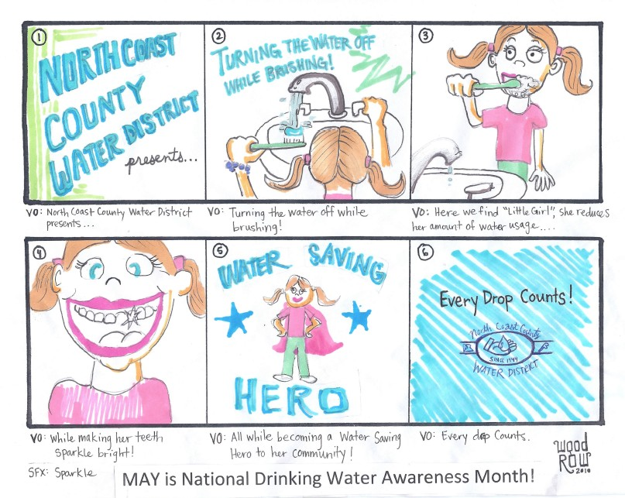
AN EXAMPLE: OF A PSA STORYBOARD

- The PSA Script

Definition:
A script is a written version of all that is said in a PSA. It includes narration (words read to an audience) and dialogue (words read in a conversation between people). Although a script is written, it is intended to be read aloud. As a result, the language of a script must be:

    - Natural and concise: written so it can be easily understood – must include camera shot directions (see above).

    - Well-organized: follows a logical order or progression.

    - Appropriately times: read at a pace that is not too fast or too slow.

    - Expressive: conveys feeling to the listener.

Preparation for creating a script:

Refer to the student sample that you were provided (it is posted on the website.)

Use the Blank Script Template we uploaded into OneDrive (it is posted on the website.)

Refer to the PSA Script Rubric

Persuasive PSA letter to Ms. McDonald

Definition:
The PSA Letter is a letter from YOU to Ms. McDonald. The purpose of the letter is for you to convince her to allow you to create a PSA for the Brighten website that will benefit the Brighten community. The PSA letter must:

- Follow the block letter format that we used in class and for your draft. You should refer to the template you were given (it is posted on the website.)
- Must include adhortative facts/stats to help your argument.
- Will use a form of Pathos, Logos and/or Ethos to make your argument.
- Will include a paragraph that explains your story idea for your PSA. Basically, describe your storyboard. You don’t have to go into a lot of detail – just give Ms. McDonald the general idea, See the example below:

Student Example: Our short PSA on pet adoption is designed to appeal to Pathos. We will show three animals up for adoption: a bird, a dog, and a frog. Two of the animals will be adopted, but the dog will be left behind. The dog then begins to cry, demonstrating the cruelty of leaving a pet without a family.

Use the PSA letter rubric you were given as reference (it is posted on the website.)

Use the PSA letter checklist you were given as reference (it is posted on the website.)

Student Evaluation Guide*

PSA Components | 3D | 3 | 2 | 1
Technical Aspects: Video reflects effective camera/film work,
editing skills, transitions, and high quality sound that add to the overall mood/message/theme of the PSA.
Structure, Variety, Pacing: Clear organizing structure, and flows
logically. Changes the screen image and/or audio on a regular basis to engage the target audience.
Creativity: The message is told in unexpected or novel ways.
Elements in the message are woven together with insight and imagination; grabbing the attention of the target audience.
Tag Line: The message is clear and concise. A single thought or phrase within the PSA summarizes the entire message.
Social Benefit: The ideas shown have an application to the lives of the targeted audience. The PSA is one that will motivate positive
behavior change to improve the health and wellness of the target audience.
Facts: The message is based on factually accurate and verifiable
information. Opinion or bias expressed is based in and supported by fact. Source information has been verified and documented.
Community Resource: Follow-up resource is provided to direct the target audience to local advocacy/support/information groups.
Cooperative Group Work: Equal division of labor; effectively completes tasks together. Resolves disagreements constructively.

Scoring Guide:
3D = The highest score possible; indicates a highly effective use of a component. Exemplary demonstration of effort and achievement throughout the PSA.
3 = Accomplished use of component(s) is consistently demonstrated throughout the video.
2 = Elements described may be present, but are inconsistently or haphazardly applied.
1 = Effort is demonstrated towards incorporating the component(s) described, but the desired results are not seen in the final product.
0 = Score reflect the absence of the desired elements

- ANY use of profanity, pejorative language, graffiti, destruction of public property, self-injurious behavior, violence, weapons, or drugs in any part of the process or product of the PSA will result in a failing grade and referral to administration

