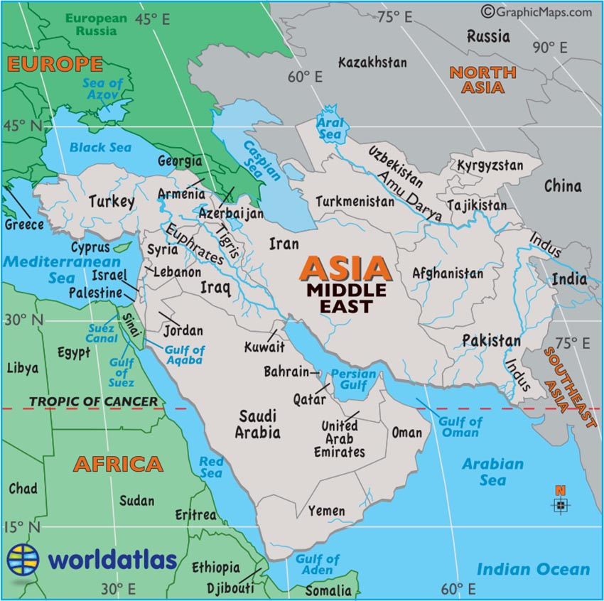Middle East Description
The so-called modern version of the Middle East sits where Africa, Asia and Europe meet. The countries of the modern Middle East are all part of Asia, but for clarity reasons we geographically show them here as a separate landmass.

The Greater Middle East Map includes all countries on the map above including Afghanistan and Pakistan, and all the other "stans," but it also includes many North African countries like Egypt, Libya and Sudan.

