Isolation room isn't best way to deal with disruptive students, parents say
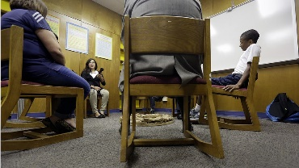
INDEPENDENCE, Mo. — One day, Kari Knudtson's 10-year-old son became disruptive in class. He was out of control. His teacher could not get him to calm down. Then the fourth-grader was sent to the school's isolation room. The isolation room is a quiet space where disruptive kids are sent. He sat there alone, thought about his behavior, and then later returned to class. Knudtson's son has had trouble with his behavior in the past. However, this was the first time Knudtson had heard of an isolation room. Schools deal with poorly behaving students in different ways. Isolation rooms are one type of consequence for kids. Not all schools have an isolation room. Schools that use them think they keep kids safe and help them with behavior. Teachers send students who are out of control to these rooms with hopes that the student will calm down after spending time alone. However, isolation rooms upset some parents. Some people believe they are not appropriate for children.
Unhappy About The Rooms
In the last few years, parents across the country have begun to protest the use of isolation rooms. Families do not like the idea of their children being held in a small room or box during the school day. Knudtson's son goes to Mill Creek Elementary in Missouri. The isolation room at his school is an empty room. It has a door that leads into the room. The district says a student can never be locked inside. Students who are sent to the room are supervised. A trained staff member will stay and watch over a student. The district said the rooms help students calm down. Once students recover, they are allowed to return to their classroom.

Some Back Use Of Isolation Space
Still, many parents are unhappy. They want Mill Creek to stop using the isolation room. Joni Gentry is one of those people. She has a fifth-grader at Mill Creek.“We didn’t need them in the past; why do we need them now?” she said.Some families say the room is unsafe. They say it has a brick wall and electrical sockets that are not covered. The sockets can be dangerous for some kids. Other parents support the school's decision to use the rooms. Some believe the rooms can help their kids behave better.

Other Methods To Help Stop Disruptions
This is not the first time that isolation rooms have been in the news. In 2012, a Washington public school held a second-grader in a small padded closet. The district called the closet an isolation room. Parents disagreed. They said it was used like a prison cell. Last year, schools in Texas held students in isolation spaces. Some of the rooms were very small. One was about the size of a parking space.Medical experts said fewer schools are using these rooms now. Schools are realizing that there are other ways to handle bad behavior. Parents are trying to force Mill Creek Elementary school to get rid of its isolation room. They will talk about their worries at a meeting with leaders from the school district.

