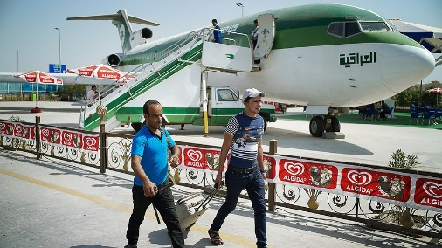BAGHDAD, Iraq — Mohammed Falah has a good life in his country compared to many other people, but he will leave it behind anyway. He is 24 years old and works as a civil engineer. His job is to build and design roads, bridges and dams. He also has his own house in Baghdad, the capital of the country of Iraq.
Iraq has about 30 million people. It is in the Middle East and there are five other countries around it. They are Jordan and Syria, Turkey and Iran, and Kuwait and Saudi Arabia. Years of war in Iraq have damaged much of the country. Many people have been killed or hurt.

Trying To Get To Europe
Falah will first fly from Iraq to Turkey. When he gets to Turkey, he will join many other people who are trying to move to the continent of Europe.
Falah is leaving Iraq because he wants a better life for his family. It is hard to get out of the country because there is fighting everywhere. However, many people are leaving now, so Falah has decided to go too.
"I saw this wave of young people who were going, many of my friends going, and I saw this as a chance," Falah said. He wants to make it to Germany. Falah will leave his wife and baby daughter behind for now, and hopes that someday they can join him.
People are getting out of Iraq because it is unsafe. The government of Iraq is worried about losing Falah and others like him who have an education and are leaving.

"I Need To Get A Future"
"I think about my country, and how it needs people like me" Falah said, "but my country hasn't given me anything. I need to get a future."
Nearly 3 million people have had to leave Iraq since Islamic State fighters began to take land there last year. The Islamic State is a violent group. It wants to start its own country under Islamic law. Its fighters have taken over parts of Syria. Some of northern and western Iraq is also under its control.
There are many groups that are fighting against the Islamic State in Iraq. These groups are called militias. They are not in the government, but fight like soldiers. All of the different groups of fighters are making it hard for the government in Iraq to make it safe.

Thousands Forced From Their Homes
The United Nations (U.N.) is an organization that most countries in the world belong to. The group is watching the refugees. The U.N. says that more than 50,000 people have left Iraq in the past three months.
There are many thousands of refugees already traveling from Iraq and other countries such as Syria. A refugee is a person who is forced out of his or her home or country.
They are all crossing through countries around the Mediterranean Sea on their way to Europe.
Not everyone can get to Europe. Iraq has set up refugee camps for people who have lost their homes because of the fighting.

Iraq Needs Its Young People
Some of the refugees cannot safely get out of the country unless they fly in a plane. The U.N says many need to fly to Turkey to escape. Unfortunately, only those who have the money can go. Arkan Naji Obaid is staying at one of the camps. He is 37 years old, and his mother is also at the camp. Obaid says, "If people had the money to go, this camp would be empty."
Iraq has suffered many wars in the last 35 years. The fighting has made it hard for Iraq to keep its talented people.
An Iraqi government worker says that each day almost 1,000 people leave the country. He is worried and says "without its young people, Iraq will never be able to rebuild."
Iraqi refugees are only some of the half million people who have escaped to Europe this year. The number of Iraqi refugees is expected to get bigger.

