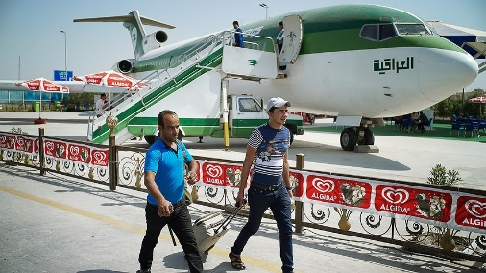
BAGHDAD, Iraq — Mohammed Falah says that his life is not so bad. After all, he has a career and a home in Iraq. However, despite his success, he is planning to leave his country.
The 24-year-old from Iraq's capitol city of Baghdad, plans to fly to Turkey next week to join the surge of migrants and refugees seeking a better life in Europe. He will also be part of what Iraqi officials describe as a "brain drain." Iraq is losing its talent as young college graduates like Falah seize what they perceive as a rare opportunity to leave their country and escape the violence. Falah, a civil engineer, will take his talent with him.

Fear Of The Islamic State
The United Nations states that more than 50,000 Iraqis have left the country, just in the past three months. They join the hundreds of thousands already making the perilous journey across the Mediterranean region, and the Mediterranean Sea. Nearly 3.2 million people have been forced out of their homes since fighters from the Islamic State group began to seize Iraqi territory early last year.
The Islamic State is an extremist group attempting to set up its own country governed by Islamic law. It has also been called Islamic State of Iraq and the Levant (ISIL) and Islamic State of Iraq and Syria (ISIS). The group's fighters have captured parts of Syria and some of northern and western Iraq.
The mass exit by Iraqis has become the fastest growing displacement crisis in the world. Displacement is when people are forced out of their homes or their country. However, Iraqi officials say a large number of those leaving are not actually displaced, but educated young men like Falah who can afford the journey.

Losing A Thousand People A Day
"I saw this wave of young people who were going, many of my friends going, and I saw this as a chance," said Falah, who hopes to eventually make it to Germany. "I'm in a better position than many people, but I want to make a better future for my family." Although many displaced families who make the potentially deadly journey travel together, Falah plans to leave his wife and 6-month-old daughter behind in Baghdad, and hopes they can join him legally once he has settled.
Joseph Sylawa, who works for the Iraqi parliament committee for migration and displacement, said it is estimated that the number of people leaving the country is as high as 1,000 per day. "It's a death blow," he said. "Without its young people, Iraq will never be able to rebuild."
Iraq has suffered several wars in the last 35 years and because of this unrest, Iraq has long struggled to hold onto its talented people. Many Iraqis returned after the fall of former dictator Saddam Hussein in 2003, but fled when fighting began again.

"I Need To Get A Future"
Now, Iraqis in Baghdad have lived through a decade of constant car bombs, more than one-quarter of the country is controlled by the Islamic State group, and a fall in oil prices is causing an economic crisis. The growing number of militia forces that are fighting the Islamic State fighters is also making it difficult for the government to control the many different armed groups on its streets. "I think about my country, and how it needs people like me," Falah said, adding that five of his friends have also left. "But my country hasn't given me anything. I need to get a future."
Like Falah, 25-year-old engineer Mohammed Jassim is also leaving. He hopes to make it to Finland. Jassim was at the top of his class when he graduated from college two years ago, but has struggled since to find a job, and now works at a car wash. He says, "My wife and my friends encouraged me to leave. There are thousands like me that are leaving. I expect to see death on the journey, but I depend on God."

Many Displaced People Still Stranded
Falah and Jassim are fortunate because not everyone can get out. In Iraq's camps for the displaced, many who have been forced to flee their homes because of the Islamic State's advance, say they cannot move on to Europe. Thousands of displaced people remain stranded in Iraq's Anbar province because they are unable to obtain permission from authorities to leave.
Anbar province is in the west and is Sunni. Shiite Muslims and Sunni Muslims are two opposing sects of Islam, and the government is worried about the security threat of allowing people into Baghdad or Iraq's south, which is Shiite.
Since it is unsafe to travel over land, Ariane Rummery, a spokeswoman for the U.N's refugee agency, says many people need to fly to Turkey to escape Iraq. Unfortunately, only those who can pay the airfare may make it out.

Losing The Best Of The Best
Thirty-seven-year-old Arkan Naji Obaid and his mother are in a camp for displaced families in Baghdad. They lost everything when they were forced to flee their home in Fallujah at the beginning of 2014, when the Islamic State group seized control. Now, they cannot afford to leave the country. "I'd tear up my identity card right now for the chance to go to Europe," said Obaid, who was badly injured after an American airstrike hit his house in 2003. He also witnessed his father's brutal murder. Obaid continued, "If people had the money to go, this camp would be empty."
Iraqis make up just 4 percent of the more than half million people who have escaped to Europe this year. However, that proportion is expected to rise. Shiite Iraqi politician Mowaffak al-Rubaie says that young, Iraqi Sunnis in particular, are struggling to envision a future. However, al-Rubaie says regardless of sect, the best of the best are leaving.

