“Hairs"
by Sandra Cisneros

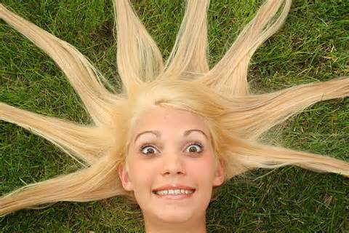

Everybody in our family has different hair. My Papa's hair is like a broom, all up in the air. And me, my hair is lazy. It never obeys barrettes or bands. Carlos' hair is thick and straight. He doesn't need to comb it. Nenny's hair is slippery--slides out of your hand. And Kiki, who is the youngest, has hair like fur.
But my mother's hair, my mother's hair, like little rosettes, like little candy circles all curly and pretty because she pinned it in pincurls all day, sweet to put your nose into when she is holding you, holding you and you feel safe, is the warm smell of bread before you bake it, is the smell when she makes room for you on her side of the bed still warm with her skin, and you sleep near her, the rain outside falling and Papa snoring. The snoring, the rain, and Mama's hair that smells like bread.

