GROWING UP IN DARFUR

Sudanese Children Struggle to Survive
Sumaya’s life used to be just like other children’s lives. She went to school, played with friends, and did chores.
But in early 2003, everything changed. Armed fighters attacked her village in Darfur, a region of Sudan, killing everyone in sight. Sumaya and her family had to run for their lives.
"We ran and ran until I felt that I couldn’t go on any longer," Sumaya recalled at the age of 15.
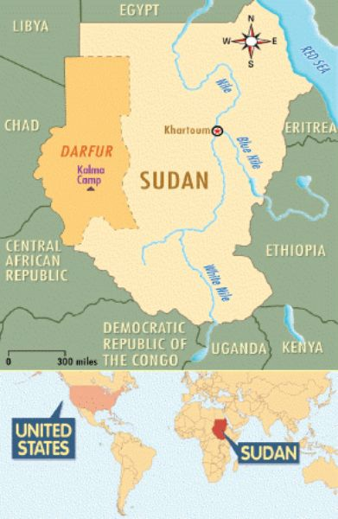
Leigh Haeger
Map of Sudan.
After walking about 100 miles, they arrived at Kalma Camp, a place for refugees in Darfur. Refugees are people who flee their homes because of war or a natural disaster.
The camp was home to more than 70,000 refugees. As of 2011, approximately 2.6 million people had abandoned their homes to escape the fierce fighting over Darfur’s scarce farmable land. Hundreds of thousands of those refugees were children, according to the United Nations.
The refugees arrived at places like Kalma Camp with little more than the clothes on their backs. Food and water were scarce, and the outlying violence often spilled into the camps. The situation was the "world’s worst humanitarian crisis," U.N. officials said.
"Tens, even hundreds, of thousands of people...need water, medical care, and food," said Pauline Horrill of Doctors Without Borders, an aid group.

Everyday Struggle
Even a few years after Sumaya had arrived at Kalma Camp, conditions in the refugee camps were bleak. Tents and mud huts were clustered as far as the eye could see. The scorching sun beat down on the desert landscape, pushing the temperature as high as 122 degrees Fahrenheit.
Stephen Winter, a U.S. doctor, helped treat some of the sickest refugees at a makeshift clinic. "Many of the people ... have to sleep on the ground," he wrote in his journal. "They share the ground with biting insects and the occasional snake."
The refugees received food rations twice a month. Sumaya used the wheat, beans, oil, salt, and powdered food mixture that her family received to make a brown, watery soup for her younger brothers and sisters.
"The food here is not nutritious," she told a U.N. aid worker. "In our village, we used to eat lots of vegetables and fruits, but we can’t grow anything here."

Hope for the Future
One bright spot in Sumaya’s life was school. She went to English classes in the camp. She also volunteered at a center where refugee children could play, draw pictures, and talk about what they’d been through.
The centers were important, explained Adolphe Mbaikouma, a UNICEF worker. "Sharing laughter helps release some bad memories," Mbaikouma said.
However, aid workers feared that more bad memories might be inevitable. Fighters had begun to attack refugee camps. The United Nations had cut the number of aid workers in the area because of the danger.
Still, Sumaya stayed positive by thinking about good things. She was thankful that her parents and brothers and sisters were alive. She daydreamed about her family’s farm and the day she would be able to return home.

