Student Name: Teacher: Date

Use the political map of Africa above to answer questions 1-7:
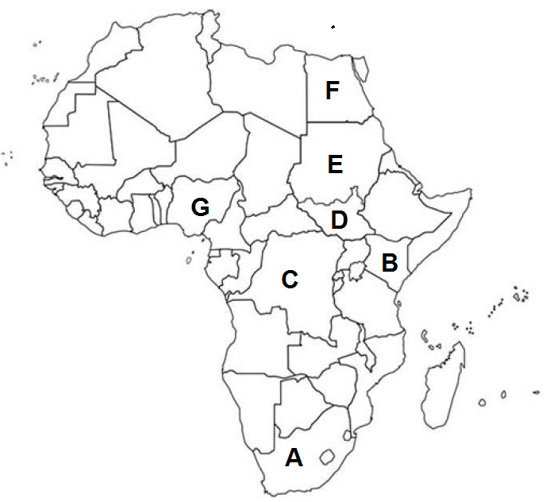
- Which country is marked by letter A_____________S. Africa
- Which country is marked by letter B? Kenya
- Which country is marked by letter C? Congo (Zaire)
- Which country is marked by letter D? _South Sudan
- Which country is marked by letter E? _Sudan
- Which country is marked by letter F? ______Egypt
- Which country is marked by letter G? _Nigeria

Use the physical map of Africa below to answer questions 8-14
(note that features are approximate):

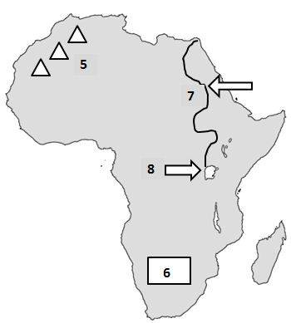

- What REGION is marked by the number 5? ___Sahara Desert
- What physical feature is marked by the number 5? __The Atlas Mountains
- What physical feature is marked by the number 6? ____The Kalahari Desert
- What REGION is marked by the number 6? __The Savannah
- What physical feature is marked by the number 7? _____The Nile River
- What physical feature is marked by the number 8? ____Lake Victoria
- What REGION is marked by the number 5? __The Sahara Desert

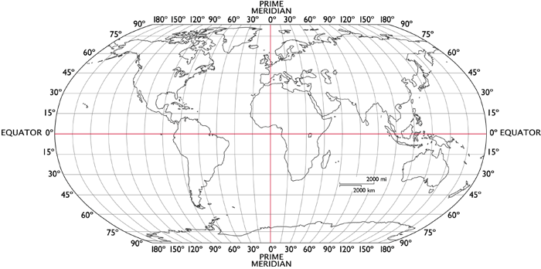

- Latitude lines run around the globe in a/an _____East-West_______ direction. They really measure the distance from the _____Equator__________.
- The boundary separating the northern and southern hemispheres is the __________Equator_______________.
- Another name for latitude lines is ______Parallel__________ because they are always the same distance apart. Latitude tells how far __N_________ or ____S____ of the equator you are.
- Longitude lines, also called ____Meridians_____________________, run in a north-south direction and meet at the poles. The one going through Greenwich, England is the first, or _____The Prime Meridian__________________________.
- The prime meridian divides the globe into two hemispheres. The one on the left is the ___Western Hemisphere________________ and the one on the right is the __Eastern Hemisphere_.
- Longitude tells how far ____E____ or _______W__ of the prime meridian you are.
- When coordinates are given, the one that is always given first is ____Latitude__.
- What continents lie mostly West of the Prime Meridian? ______North and South America__________________________
- What continents lie mostly North of the Equator? ______N.A., Europe, Asia, Africa (1/2),
- What continents lie mostly East of the Prime Meridian? __Africa, Europe, Asia and Australia
- What continents lie mostly South of the Equator? ___ Africa (1/2) , South America, Antarctica and Australia
Use the map to answer the following questions about latitude and longitude.
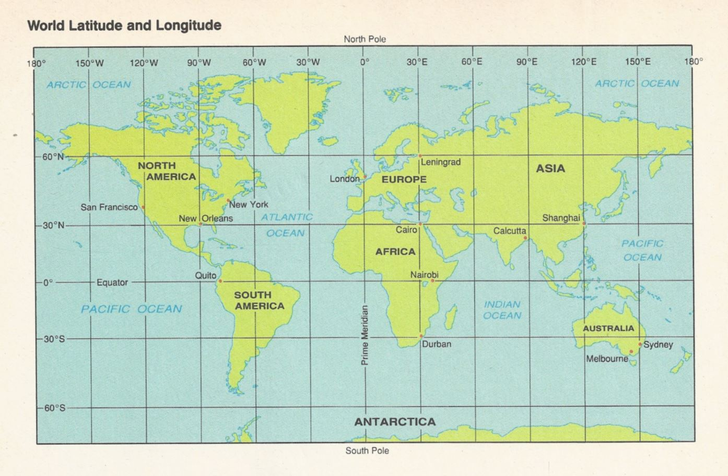
- On what continent would you find the place with a latitude of 20° N and a longitude of 0°?
a. Europe b. Asia c. Africa d. South America

- On what continent would you find each of the following locations?
  - 60°N, 100°W ______N.America___
  - 60°N, 100°E __Asia
  - 20°S, 60°W ___S. America

- Identify the city and lies closest to each pair of coordinates.
  - 30°N, 90°W ___New Orleans
  - 30°N, 30°E __Ciaro

- Give the coordinates for each city.
  - Shanghai, China ____30 N 120 E___
  - Durban, South Africa __30 S 30 E

- Identify the city with each pair of coordinates.
  - 0°, 78°W _____Quito
- 38°S, 145°E ____Melbourne

- Estimate the coordinates for each city to the nearest degree.
  - Calcutta, India 25 N 89W
  - Nairobi, Kenya 30 E 0
  - New York, New York 40 N 80 W
- 51°N, 0° _____London

