Student Name: Teacher: Date

Use the political map of Africa above to answer questions 1-7:
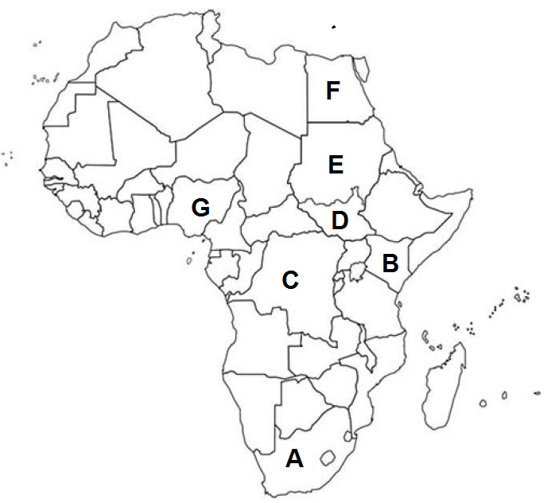
- Which country is marked by letter A__________________________________
- Which country is marked by letter B? __________________________________
- Which country is marked by letter C? __________________________________
- Which country is marked by letter D? __________________________________
- Which country is marked by letter E? __________________________________
- Which country is marked by letter F? __________________________________
- Which country is marked by letter G? __________________________________

Use the physical map of Africa below to answer questions 8-14
(note that features are approximate):

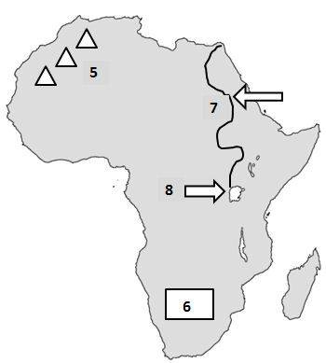

- What REGION is marked by the number 5? ________________________________________
- What physical feature is marked by the number 5? __________________________________________
- What physical feature is marked by the number 6? __________________________________________
- What REGION is marked by the number 6? __________________________________________
- What physical feature is marked by the number 7? __________________________________________
- What physical feature is marked by the number 8? __________________________________________
- What REGION is marked by the number 5? ______________________________________________

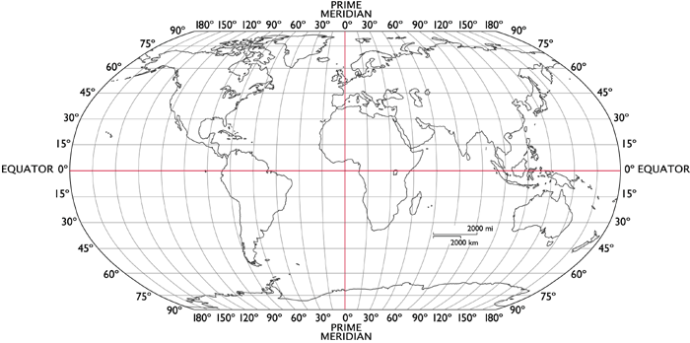

- Latitude lines run around the globe in a/an ____________ direction. They really measure the distance from the _______________.
- The boundary separating the northern and southern hemispheres is the _________________________.
- Another name for latitude lines is ________________ because they are always the same distance apart. Latitude tells how far ___________ or ________ of the equator you are.
- Longitude lines, also called _________________________, run in a north-south direction and meet at the poles. The one going through Greenwich, England is the first, or _______________________________.
- The prime meridian divides the globe into two hemispheres. The one on the left is the ___________________ and the one on the right is the ___________________.
- Longitude tells how far ________ or _________ of the prime meridian you are.
- When coordinates are given, the one that is always given first is ____________________________.
- What continents lie mostly West of the Prime Meridian? ________________________________________
- What continents lie mostly North of the Equator? ______________________________________________
- What continents lie mostly East of the Prime Meridian? ________________________________________
- What continents lie mostly South of the Equator? ______________________________________________
Use the map to answer the following questions about latitude and longitude.
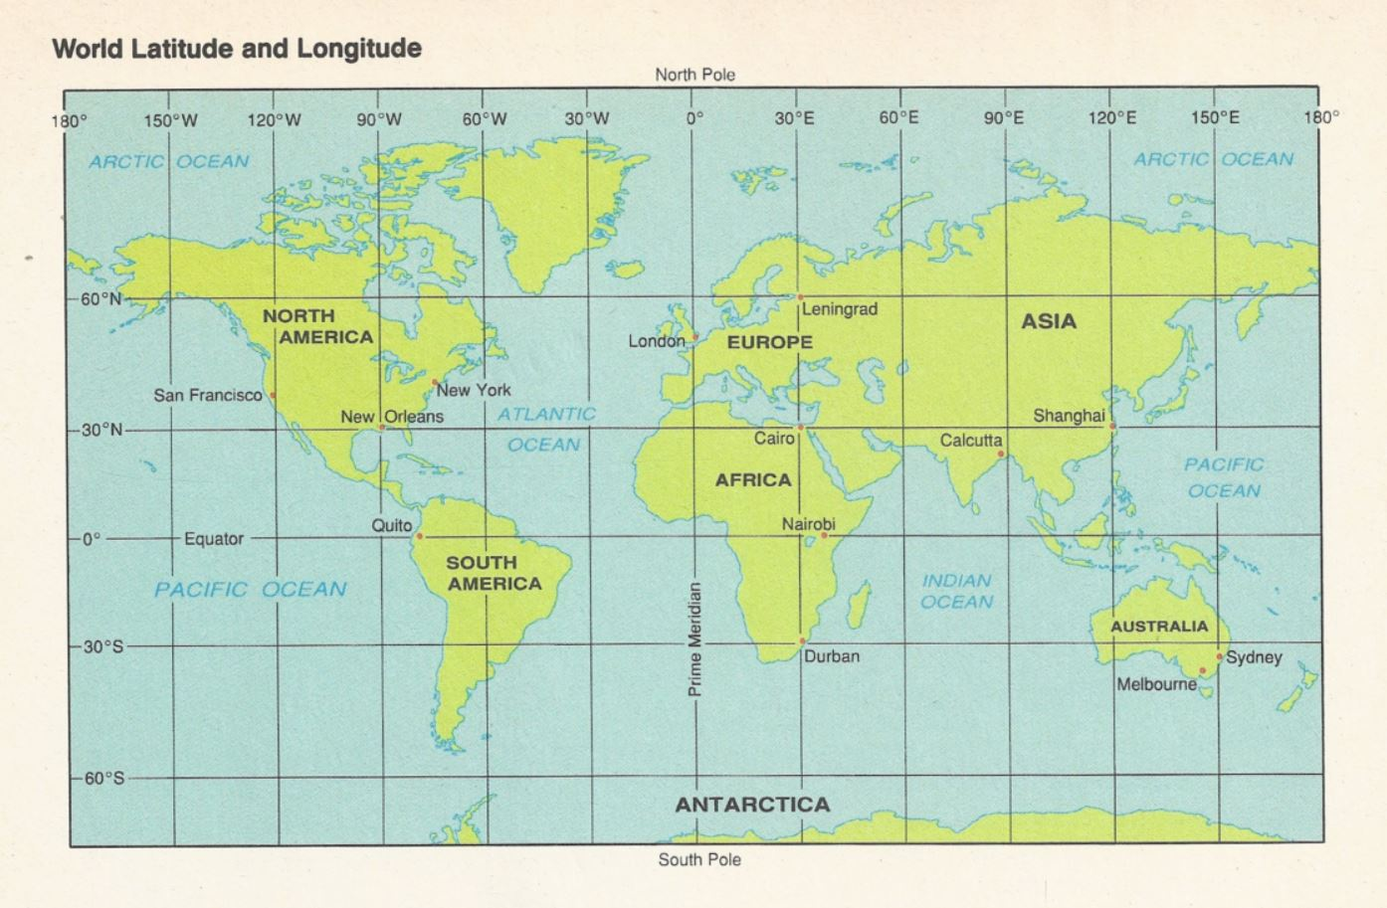
- On what continent would you find the place with a latitude of 20° N and a longitude of 0°?
a. Europe b. Asia c. Africa d. South America

- On what continent would you find each of the following locations?
  - 60°N, 100°W _________________________
  - 60°N, 100°E ________________________
  - 20°S, 60°W _______________________

- Identify the city and lies closest to each pair of coordinates.
  - 30°N, 90°W ________________________
  - 30°N, 30°E ________________________

- Give the coordinates for each city.
  - Shanghai, China ____________________
  - Durban, South Africa _________________

- Identify the city with each pair of coordinates.
  - 0°, 78°W ___________________________
  - 51°N, 0° __________________________
  - 38°S, 145°E ________________________

- Estimate the coordinates for each city to the nearest degree.
  - Calcutta, India ________________________
  - Nairobi, Kenya ________________________
  - New York, New York ___________________

