Africa Political – GAPMINDER Map Analysis Name Date

Use GAPMINDER to determine the life expectancy and income per person for each of the countries we are studying.

Egypt | Kenya | Democratic Republic of Congo (Zaire)
South Sudan | Sudan
South Africa | Nigeria

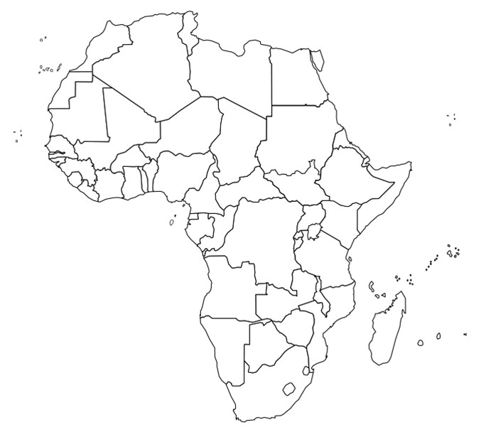
Q1. Based on your analysis, which of the African nations above has the highest quality of life?

Q2. Based on your analysis, which of the African nations above has the lowest quality of life?

Q3. Based on your interpretation of the GAPMINDER graph, which world nation has the highest quality of life and which has the lowest?

South Africa

Congo
Nigeria
Kenya
South Sudan
Sudan
Egypt

