Gapminder Fill-in Map Name Date

Identify the following countries of Africa AND use GAPMINDER to indicate the Income and LIFE EXPECTENCY on the map below:

Egypt | Kenya | Democratic Republic of Congo (Zaire)
South Sudan | Sudan
South Africa | Nigeria
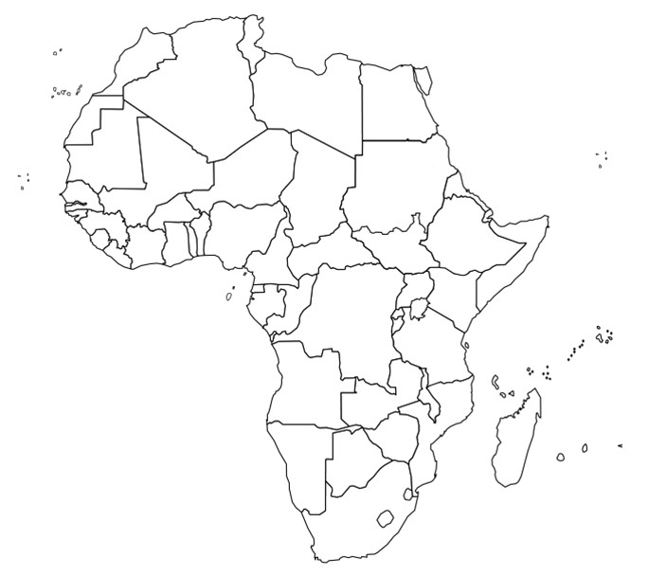
South Africa
Income – $12,000
Life Expectancy – 63.5yrs

QUESTION
- WHAT AFRICAN NATION WE ARE STUDYING HAS THE HIGHEST INCOME (give data)?

- WHAT AFRICAN NATION WE ARE STUDYING HAS THE LOWEST INCOME (give data)? ?

- WHAT AFRICAN NATION WE ARE STUDYING HAS THE LOWEST LITERACY RATE (give data)?

- IS THERE A CONNECTION BETWEEN LITERACY RATE AND INCOME? CITE THE MAP DATA TO SUPPORT YOUR ANSWER.

South Africa

GDP - $12,000

Capital - Pretoria

