Beijing's smoggy air is affecting students inside China's classrooms
By Robert Brown – www.latimes.com/china 01.13.16

Young tourists wear masks as they stand near a Chinese paramilitary policeman in Tiananmen Square in Beijing, China, Dec. 19, 2015. Smog built up in the Chinese capital as the second red alert of the month went into effect, forcing many cars off the roads and restricting factory production. AP/Ng Han Guan
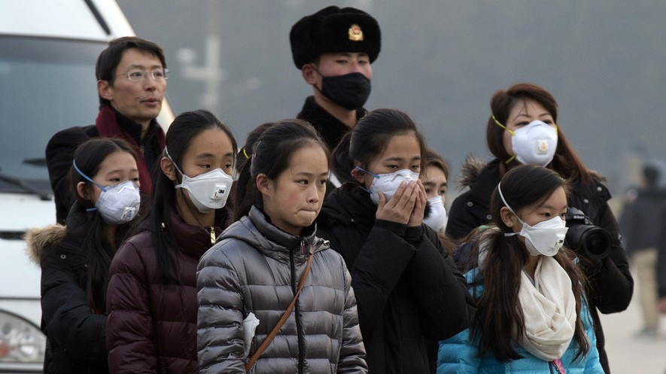
BEIJING, China — First came the air pollution, and then came the government's failure to deal with it.
Sara Zhang is like many people who live in Beijing. She has taken steps at home to protect herself and her two children from the city’s extreme air pollution. Yet her 7-year-old son’s public school has not installed any air puriﬁers. These machines improve air quality and are common in the city's expensive private schools. The students in her son's school have no choice but to breathe the toxic air.
Zhang, 39, recently joined other parents to oﬀer a few air puriﬁers to the school at no cost. Yet school leaders refused to take them, saying the government had not approved their use. This led to Zhang's nightmarish experience.
“We called the (local) education committee, and the Education Ministry, and we got diﬀerent answers from everyone who picked up the phone,” Zhang said. “Some said that no air puriﬁers have been deemed acceptable for classrooms. Some said we should write up suggestions and they’d report to their superiors. But everyone basically told us that it’s impossible to have them installed.”

1

"Red Alert" Days

December was one of Beijing's worst months for air pollution in recent memory. Authorities announced two “red alert” smog warnings. This caused schools to close across the city.
Yet even on normal days, the city was shrouded in a toxic haze. The reluctance of many public schools to install air puriﬁers has infuriated parents. It has also shown that the Chinese government is unable to deal with some immediate eﬀects of the country’s environmental crisis.
A representative of the city’s oﬃcial school board said by phone that the board does not “encourage” schools to accept air puriﬁers from parents.
“We encourage schools to suspend classes on heavy pollution days,” the representative said.
She added that the schools are working with government and academic oﬃcials to come up with a plan that will help clean the air in schools. She did not say when the plan would be put in place.

Public Schools Lack Clean Air

Experts say China’s air pollution is very bad for human health. A 2013 study claimed up to a half-million people in China die prematurely every year because of smog.
“The nation’s air quality has become so terrible that many government departments have installed air puriﬁers in their oﬃces," an essay in the Global Times newspaper said.
The paper, which is run by the Chinese government, added: “Public oﬃcials are apparently more important than children. Few if any public schools in China are equipped with air-purifying machines..."

Intense Smog Forcing Families To Move

One woman said her 18-year-old stepdaughter’s schools had not installed air puriﬁers. She said that after the recent period of intense smog, she decided to move her family to Hainan. This island in China's deep south has some of the country's cleanest air.
“Smoggy days in Beijing are so, so common now. This happens at least once or twice a week,” said the woman, who gave only her family name, Wang. She did not want to publicly criticize the government out of fear she would be punished. "They can’t make students stay at home every week indeﬁnitely. And a lot of parents work full time; they can’t stay home from work once or twice a week to take care of their children.
“The pollution is so bad it makes life in this city practically unlivable,” she said. “This is such a massive problem, and the government isn’t solving it. So what kinds of problems is the government here to solve?”
TASK: After you read the article please create an EASY bibliography citation below (you can use your notes):p
___________________________________________________________________________________________________________________________________________
___________________________________________________________________________________________________________________________________________

3

