6th-grade student arrested for writing note, threatening to shoot up Davie school

Girl claims another student made her put note under office door, police say
By Amanda Batchelor - Senior Digital Editor
Posted: 4:16 PM, February 15, 2018

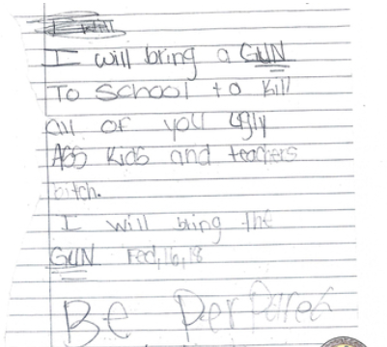
DAVIE, Fla. - A sixth-grade student at Nova Middle School in Davie was arrested Thursday for writing a note, threatening to shoot up the school, authorities said.
Davie police said the 11-year-old girl placed the handwritten note under the assistant principal's office door, which read: "I will bring a gun to school to kill all of you ugly ass kids and teachers bitch. I will bring the gun Feb. 16, 18. BE prepared bitch!"
Authorities said surveillance video shows the student placing the note under the door.
She also provided a written confession, officers said.
According to a police report, the girl was crying and upset when she was confronted by officers about the note.
In her written confession, the student claimed that another girl ordered her to put the note under the door to the assistant principal's office or she would get her friend to fight her.
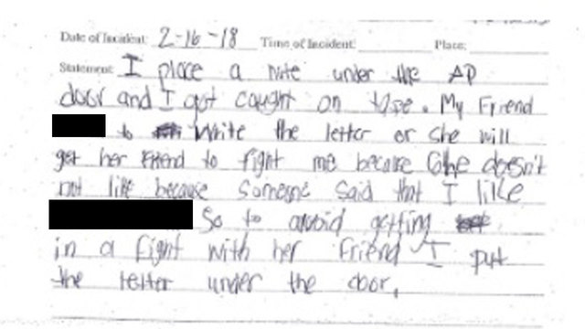
The girl said the other student didn't like her because of a boy.
The student was arrested and taken to the Broward Juvenile Assessment Center.
Local 10 News is withholding her name because of her age.
The arrest comes a day after Nikolas Cruz, 19, was arrested in connection with a mass shooting at Marjory Stoneman Douglas High School that left 17 people dead.

