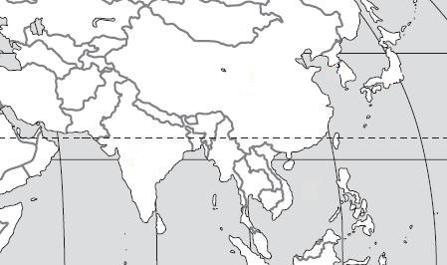
Use the maps to locate the geographic features in each question.

D
E
B
C

A

1. Bay of Bengal B
2. South China Sea C
3. Sea of Japan E
4. Yellow Sea D
5. Indian Ocean A
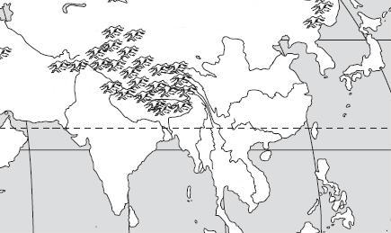

B
A
C
E
D

6. Huang He (Yellow) River E
7. Chiang Jiang (Yangtze) River D
8. Indus River A
9. Ganges River B
10. Mekong River C

D
C
A4
B

11. Taklimakan Desert B
12. Gobi Desert A
13. Himalayan Mountains D
14. Korean Peninsula C
B
E
D
F
C
A
G

15. Japan G
16. China D
17. Vietnam B
18. Indonesia C
19. India A
20. North Korea E
21. South Korea F

