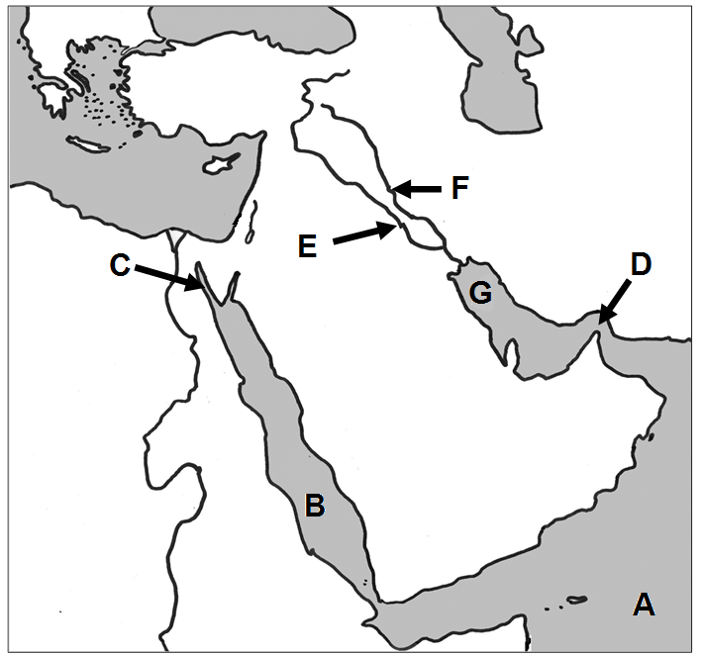
9043 Use the maps to locate the geographic features in each question.

1. Arabian Sea A
2. Euphrates River E
3. Persian Gulf G
4. Red Sea B
5. Strait of Hormuz D
6. Suez Canal C
7. Tigris River F
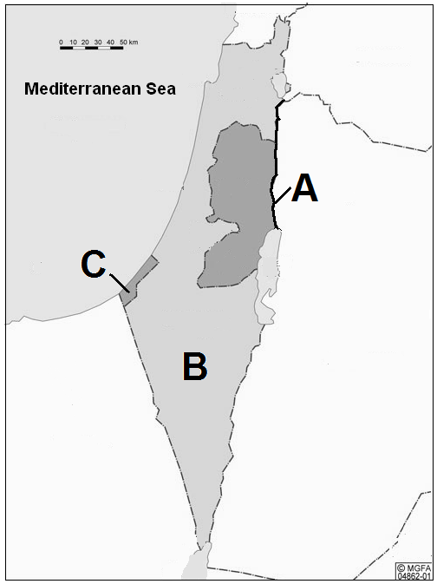

8. Gaza Strip C

9. Israel B
10. Jordan River A
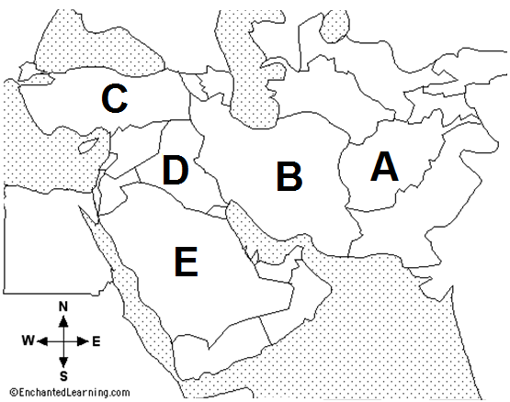

11. Afghanistan A
12. Iran B
13. Iraq D
14. Saudi Arabia E
15. Turkey C

