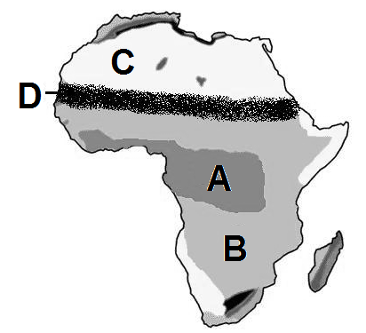
Use the maps to locate the geographic features in each question.

1. Sahara
2. Sahel
3. Savanna
4. Tropical Rain Forest
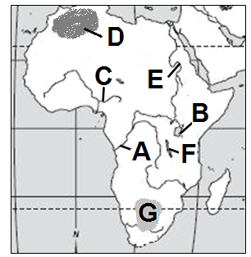

5. Atlas Mountains
6. Congo River
7. Kalahari Desert
8. Lake Tanganyika
9. Lake Victoria
10. Niger River
11. Nile River
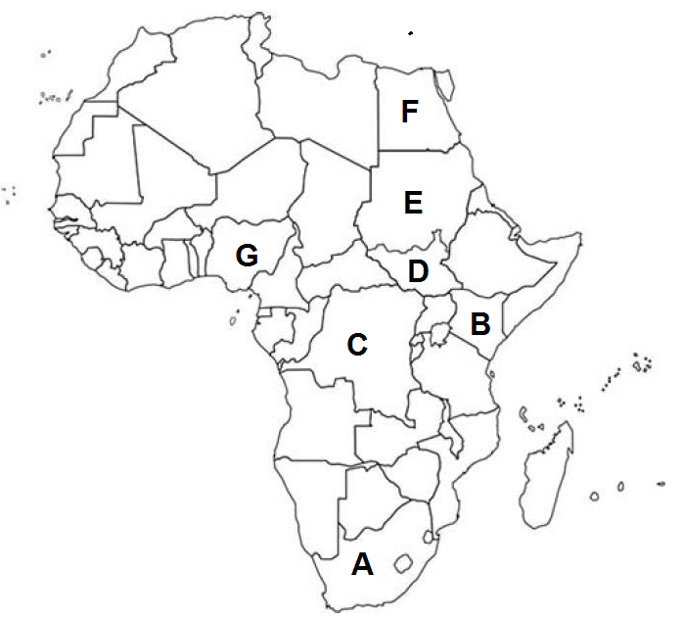

12. Congo (Zaire)
13. Egypt
14. Kenya
15. Nigeria
16. South Africa
17. Sudan
18. South Sudan

